

***Operating Lease Support System Phase-2 Project***

***for***



***Functional Specification***

***FC.AE.1.1***

***Billing Creation***

Revision 0.1

**PT. Berlian Sistem Informasi**

KTB Annex Bld. 4th Floor, Jl. Jend. A. Yani. Pulomas,

Tel. +62 21 4786 7575 (Hunting) Fax. +62 21 4714964 www.bsi.co.id

Document Control

|  |  |
| --- | --- |
| **Author** | Amal Hamzah |
| **File Name** |  |
| **Directory Address** |  |
| **Number of Page** |  |

Revision History

|  |  |  |  |
| --- | --- | --- | --- |
| **Date** | **Revision** | **Description** | **Author** |
| 15/01/2016 | 0.0 | Initialization | Amal Hamzah |
| 22/01/2016 | 0.1 | Update Screen Design, Component Screen Functionality, Operation Description and Data Structure | Amal Hamzah |
|  |  |  |  |
|  |  |  |  |

Distribution List

|  |  |  |
| --- | --- | --- |
| Name | Organization | Roles |
| Mr. Yutaro Sanada | Dipo Star Finance, PT | DSF Project Director |
| Mr. Shinji Hosokawa | Dipo Star Finance, PT | DSF Project Director |
| Mr. Shinya Tsukamoto | Dipo Star Finance, PT | DSF IT Advisor |
| Mr. Ahmad Fikri | Dipo Star Finance, PT | DSF IT Advisor |
| Mr. Roby Wijaya | Dipo Star Finance, PT | DSF PMO |
| Mr. Abdul Somad | Dipo Star Finance, PT | DSF Biz. Operation Leader |
| Mr. Mukhlis Ibrahim | Dipo Star Finance, PT | DSF IT Operation Leader |
| Mr. Delta Riangga | Dipo Star Finance, PT | DSF Key User |
| Mr. Mochamad Idris | Dipo Star Finance, PT | DSF Key User |
| Mrs. Herni Hembang | Dipo Star Finance, PT | DSF Key User |
| Mr. Junaidi Didy | Dipo Star Finance, PT | DSF Key User |
| Mr. Dedi Supriyadi | Dipo Star Finance, PT | DSF Key User |
| Mrs. Elke Hilviana | Dipo Star Finance, PT | DSF Key User |
| Mr. Daiki Kamada | Berlian Sistem Informasi, PT | BSI Project Director |
| Mr. Yoshinori Kawahara | Berlian Sistem Informasi, PT | BSI IT Advisor |
| Mr. Satoshi Koibuchi | Berlian Sistem Informasi, PT | BSI IT Advisor |
| Mr. Grand Zah Putra | Berlian Sistem Informasi, PT | BSI Project Manager |
| Mr. Raymond | Berlian Sistem Informasi, PT | BSI Technical Leader |
| Mr. Amal Hamzah | Berlian Sistem Informasi, PT | BSI Business Analyst |

Document Approval

By signing this document I acknowledge I have read the document and give the Project Management Team approval to proceed.

|  |  |  |  |
| --- | --- | --- | --- |
| Role | Name | Signature | Date |
| DSF Project Director | Mr. Yutaro Sanada |  |  |
| DSF Project Director | Mr. Shinji Hosokawa |  |  |
| DSF IT Advisor | Mr. Shinya Tsukamoto |  |  |
| DSF IT Advisor | Mr. Ahmad Fikri |  |  |
| DSF PMO | Mr. Roby Wijaya |  |  |
| DSF DSF Biz. Operation Leader | Mr. Abdul Somad |  |  |
| DSF IT Operation Leader | Mr. Mukhlis Ibrahim |  |  |
| BSI Project Director | Mr. Daiki Kamada |  |  |
| BSI Project Manager | Mr. Grand Zah Putra |  |  |
| BSI Technical Leader | Mr. Raymond |  |  |
| BSI Business Analyst | Mr. Amal Hamzah |  |  |

Table of Contents

Document Control 2

Revision History 2

Distribution List 3

Document Approval 4

1 Introduction 6

1.1 Purpose 6

1.2 Scope 6

1.3 Definition, Acronyms, and Abbreviations 6

1.1 References 7

2 Configuration 7

3 Specification Detail: FC.AE.1.1 Billing Creation 8

3.1 Purpose 8

3.2 Screen of Configuration Access 8

3.3 Screen Functionality 8

3.4 Operation Flow 9

3.5 Screen Design 12

3.6 Component Screen Functionality 20

3.7 Operation Description 29

3.8 Screen Item List 46

3.9 Data Structure 52

3.10 Entity Relationship Diagram 61

* 1. Introduction
  2. Purpose

Functional Specification is a document to describe the detail of functions system which includes screen design, report and logic formula. This document will be used for system development.

* 1. Scope

Functional Specification Document contains screen design, screen functionality, process flow, and data structure of AE.1.1 Create Billing

Here are the scope for AE.1.1 Create Billing:

1. **AE.1.1.1 Create Billing Schedule**

To generate billing schedule after agreement has already activated

1. **AE.1.1.4 Create Billing**

To update monthly billing before create invoice

1. **AE.1.1.7 Input Payment Billing**

To monitor billing payment schedule before due date

1. **AE.1.1.9 Print Invoice**

To create invoice of instalment, receipt and invoice of maintenance

1. **AE.1.1.10 Monitor Invoice Approval Process**

To monitor approval process of invoice

1. **AE.1.1.11 Edit Billing**

To modify billing

Output from this functions is:

1. RPT.AE.1.1 Billing History report
2. PF.AE.1.1 Invoice and Receipt
   1. Definition, Acronyms, and Abbreviations
3. OPL = Operating Lease
4. Due Date = End Usage Unit Date + TOP
5. TOP = Term Of Payment
6. RAL = Return Authorization Letter (Surat Kuasa Penarikan Unit)
7. BAST = Berita Acara Serah Terima (Handover Report)
8. DSF = Dipo Star Finance
9. HO = Head Office
10. HOB = Head of Branch
11. HOD = Head of Department
12. PIC = Person in Charge
13. Receipt = Kwitansi
14. Notification Letter (Surat Pemberitahuan)
15. Warning Letter (Surat Peringatan)
16. Receive Letter (Surat Tanda Terima)
    1. References

This functional specification document refers to **“To Be Design” BSI Billing Collection Process**, module:

1. AE.1.1 Billing Creation
   1. Configuration

Here will be described the format of Invoice, Receipt and Receive Letter document which will be generated when PIC Collection click Save as Draft button. The format of these document numbers are:

No. Invoice Installment : 00001/INV/CABANG/MONTH/YEAR

No. Receipt : 00001/KW/CABANG/MONTH/YEAR

No. Invoice Maintenance : 00001/CSD-INV/CABANG/MONTH/YEAR

No. Maintenance Receipt : 00001/CSD-KW/CABANG/MONTH/YEAR

No. Receive Letter (Surat Tanda Terima) : 00001/OPL/TTD/CABANG/MONTH/YEAR

Description:

* The first 5 digits show the sequence number of the Invice, Receipt and RAL documents. This number will increments whenever new Invoice, Receipt and RAL documents is created.
* The code on 3 digits for:

1. INV represents Instalment Invoice document
2. KW represents Receipt document
3. CSD-INV represents Maintenance Invoice document
4. CSD-KW represents Maintenance Receipt document
5. OPL/TTD represents Receive Letter (Surat Tanda Terima)

* The code ‘CABANG’ will be substituted by OPL Branch’s code
* The code ‘MONTH’ will be substituted by 2 digits of month when the document created.
* The code ‘YEAR’ will be substituted by 4 digits of year when the document is created.
  1. Specification Detail: FC.AE.1.1 Billing Creation
  2. Purpose

Screen of Billing Creation will be used by PIC Collection to generate billing schedule, edit billing, create/print invoice, convert invoice to excel/pdf and input payment history on monthly base.

This function covered by **“Billing Creation”** screen

* 1. Screen of Configuration Access

Here are the access rights for **“Billing Creation”** screen users:

|  |  |  |  |  |
| --- | --- | --- | --- | --- |
| ***User*** | ***Create*** | ***Read*** | ***Update*** | **Authorization** |
| PIC Collection | v | v | v | - |
| Admin | v | v | v | - |
| Head of Branch | - | v | - | - |
| Head of Department | - | v | - | - |
| Regional Manager | - | v | - | - |
| Advisor | - | v | - | - |
| Director | - | v | - | - |
| President Director | - | v | - | - |
| Shareholder’s Meeting | - | v | - | - |

Legend: v = Have the Access

Note:

1. Create: related to creation of billing schedule and invoice
2. Read: related to read display data billing schedule and invoice
3. Update: related to update data billing schedule and invoice
4. Print: related to print data of invoice
5. Authorization: related to approval process of invoice
   1. Screen Functionality
6. Update Billing Schedule
7. Create Invoice
8. Input Payment Billing
9. Monitor Invoice Approval Process
10. Print List of Invoice
11. Print Installment Invoice, Installment Receipt, Maintenance Invoice, Maintenance Receipt and Receive Letter
    1. Operation Flow

Below is operation flow for View Billing & Payment History Inquiry process refer to **To Be Design Document Billing Collection**, AE.1.1. Billing Creation Schedule:

|  |  |
| --- | --- |
| **PIC PC** | **Process** |
|  | Note:  Source  Output & Input    Billing Payment Schedule  (TB_BIL_PaySchedule)  Agreement  (OPLAgreement)  Billing Payment Schedule Detail  (TB_BIL_PayScheduleDetail)  Agreement Detail  (OPLAgreementDetail) |

Below is operation flow for Edit Billing & Payment History Inquiry (on TBD was Edit Billing) process refer to **To Be Design Document Billing Collection**, AE.1.1. Billing Creation Schedule:

|  |  |
| --- | --- |
| **PIC PC** | **Process** |
|  | Note:  Source  Output & Input    Billing Payment Schedule  (TB_BIL_PaySchedule)  Agreement  (OPLAgreement)  Billing Payment Schedule Detail  (TB_BIL_PayScheduleDetail)  Agreement Detail  (OPLAgreementDetail) |

Below is operation flow for Add Billing & Payment History Detail process refer to **To Be Design Document Billing Collection**, AE.1.1. Billing Creation Schedule:

|  |  |
| --- | --- |
| **PIC PC** | **Process** |
|  | Note:  Source  Output & Input    Billing Payment Schedule  (TB_BIL_PaySchedule)  Agreement  (OPLAgreement)  Billing Payment Schedule Detail  (TB_BIL_PayScheduleDetail)  Agreement Detail  (OPLAgreementDetail) |

Below is operation flow for Edit Billing & Payment History Detail process refer to **To Be Design Document Billing Collection**, AE.1.1. Billing Creation Schedule:

|  |  |
| --- | --- |
| **PIC PC** | **Process** |
|  | Note:  Source  Output & Input    Billing Payment Schedule  (TB_BIL_PaySchedule)  Agreement  (OPLAgreement)  Billing Payment Schedule Detail  (TB_BIL_PayScheduleDetail)  Agreement Detail  (OPLAgreementDetail) |

Below is operation flow for Monitor Invoice Approval process refer to **To Be Design Document Billing Collection**, AE.1.1. Billing Creation Schedule:

|  |  |
| --- | --- |
| **PIC PC** | **Process** |
|  | Note:  Source  Output & Input    Invoice Receipt  (TB_BIL_InvoiceReceipt)  Billing Payment Schedule Detail  (TB_BIL_PayScheduleDetail)  Billing Payment Schedule  (TB_BIL_PaySchedule) |

Below is operation flow for Create Invoice process refer to **To Be Design Document Billing Collection**, AE.1.1. Billing Creation Schedule:

|  |  |
| --- | --- |
| **PIC PC** | **Process** |
|  | Note:  Source  Output & Input    Invoice Receipt  (TB_BIL_InvoiceReceipt)  Billing Payment Schedule Detail  (TB_BIL_PayScheduleDetail)  Billing Payment Schedule  (TB_BIL_PaySchedule) |

Below is operation flow for View Invoice Approval Status process refer to **To Be Design Document Billing Collection**, AE.1.1. Billing Creation Schedule:

|  |  |
| --- | --- |
| **PIC PC** | **Process** |
|  | Note:  Source  Output & Input    Invoice Receipt  (TB_BIL_InvoiceReceipt)  Billing Payment Schedule Detail  (TB_BIL_PayScheduleDetail)  Billing Payment Schedule  (TB_BIL_PaySchedule) |

* 1. Screen Design
* *Initial Screen View Billing & Payment History Inquiry*

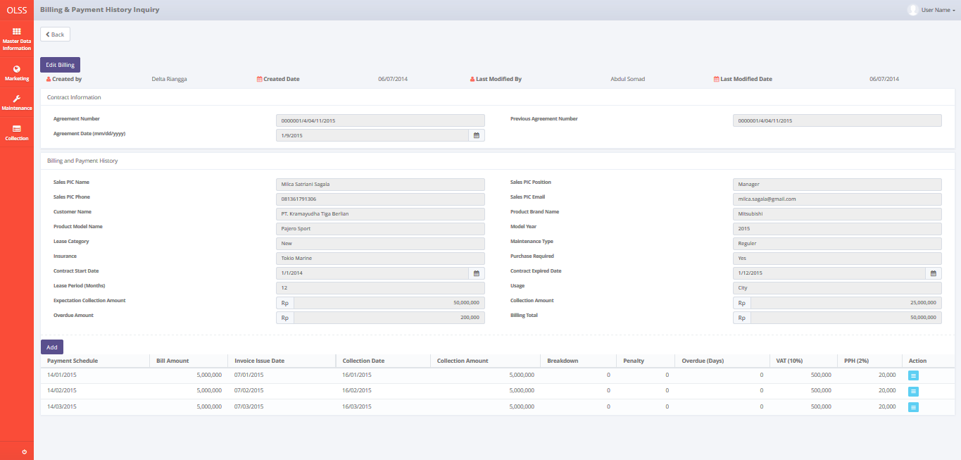

*Screen 1. View Billing & Payment History Inquiry*

* *Screen Design of Edit Billing & Payment History Inquiry*

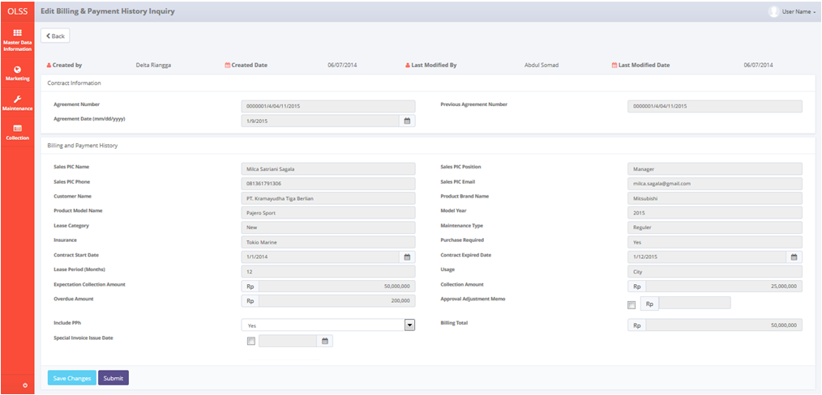

*Screen 2. Edit Billing & Payment History Inquiry*

* *Screen Design of Add Billing & Payment History Detail*

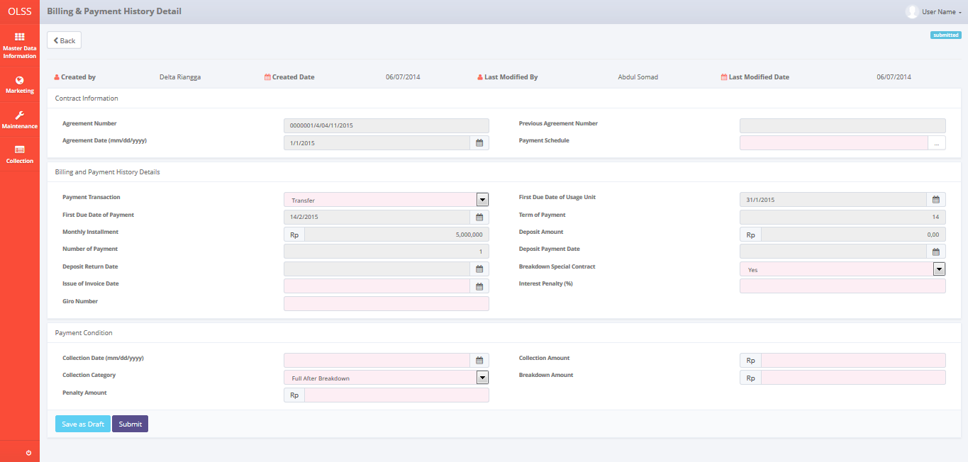

*Screen 3. Add Billing & Payment History Detail*

* *Screen Design of Edit Billing & Payment History Detail*

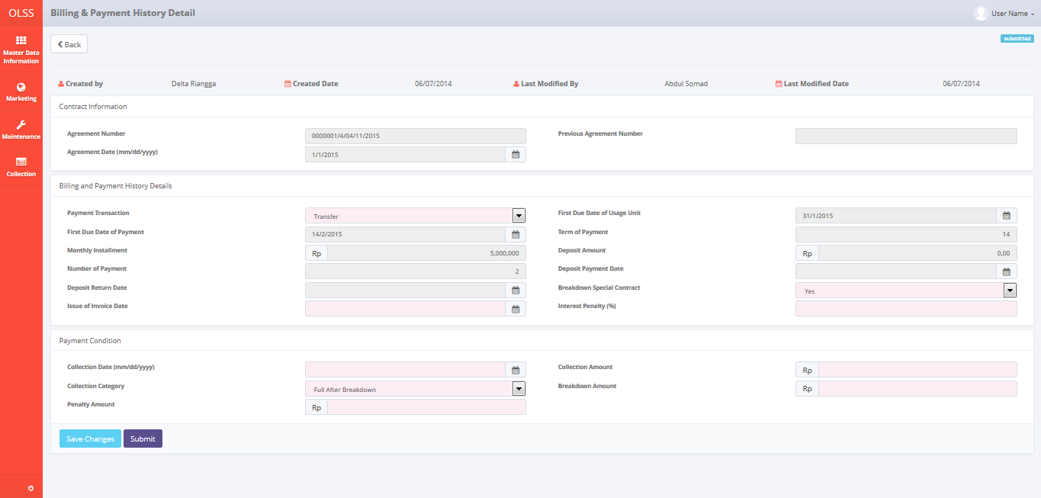

*Screen 4. Edit Billing & Payment History Detail*

* *Screen Design of Create Invoice*

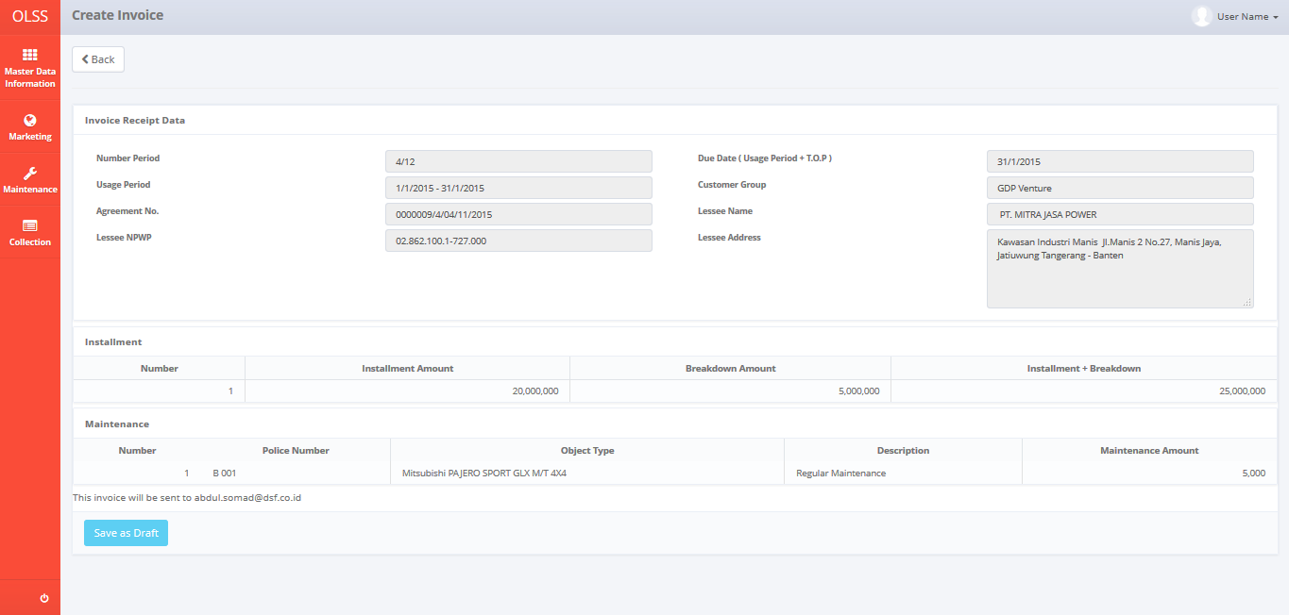

*Screen 5. Create Invoice*

* *Screen Design of List Invoice Status Approval*

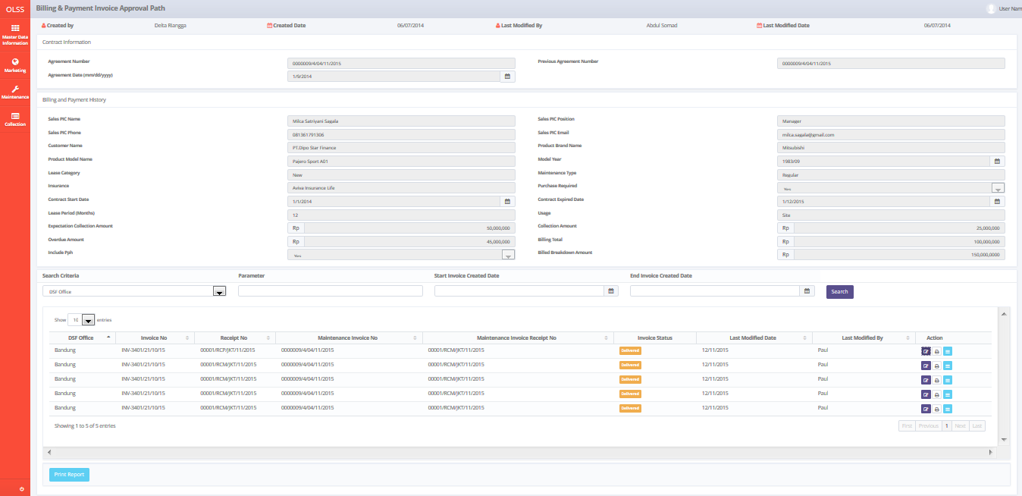

*Screen 6. List of Invoice Status Approval*

* *Screen Design of View Invoice Status Approval*

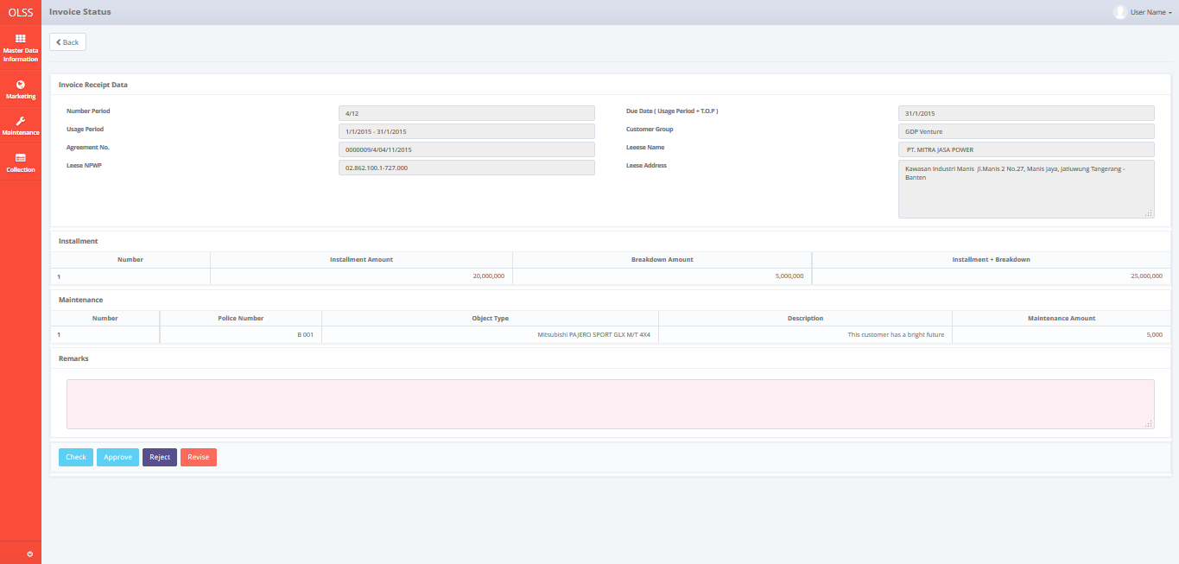

*Screen 7. Invoice Status Approval*

* *Screen Design of Edit Delivery Invoice*

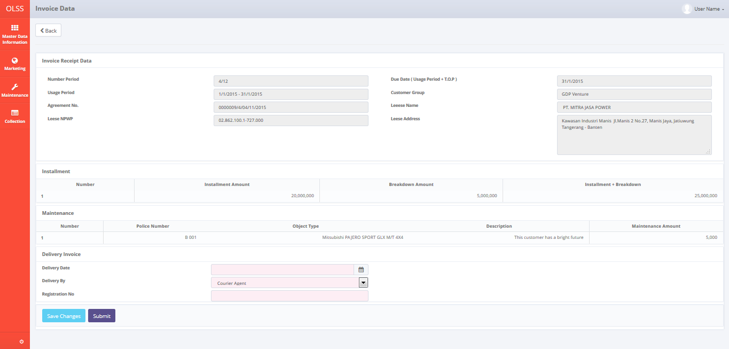

*Screen 8. Edit Delivery Invoice*

* *Screen Design of Print View Installment Invoice*

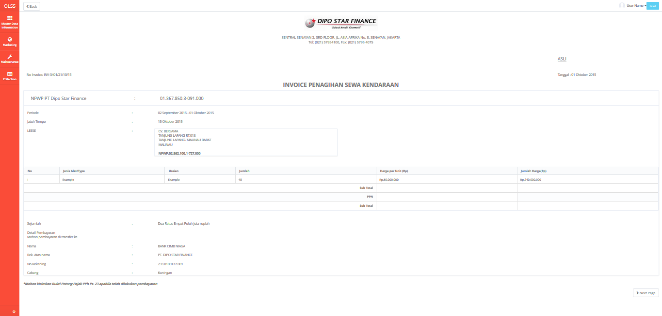

*Screen 9. Installment Invoice*

* *Screen Design of Print View Installment Receipt*

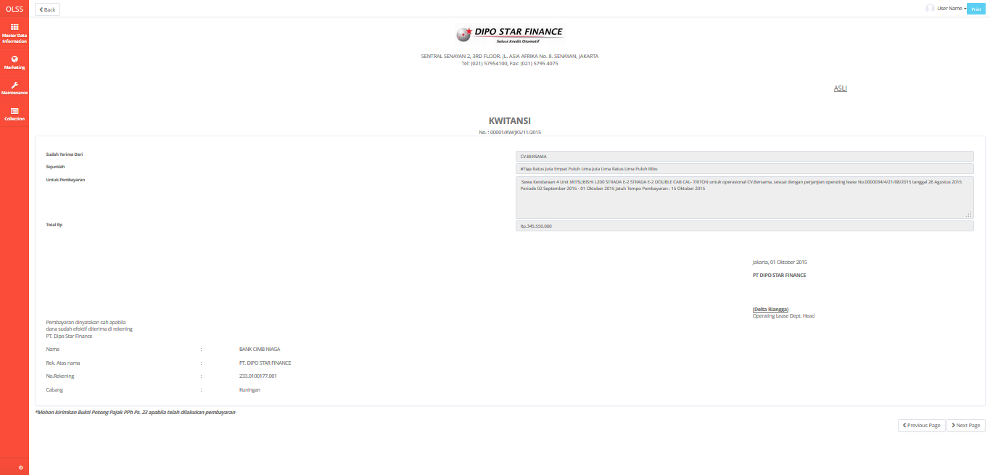

*Screen 10. Installment Receipt*

* *Screen Design of Print View Maintenance Invoice*

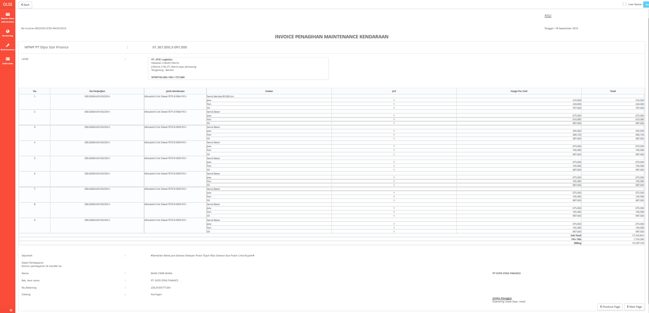

*Screen 11. Maintenance Invoice*

* *Screen Design of Print View Maintenance Receipt*

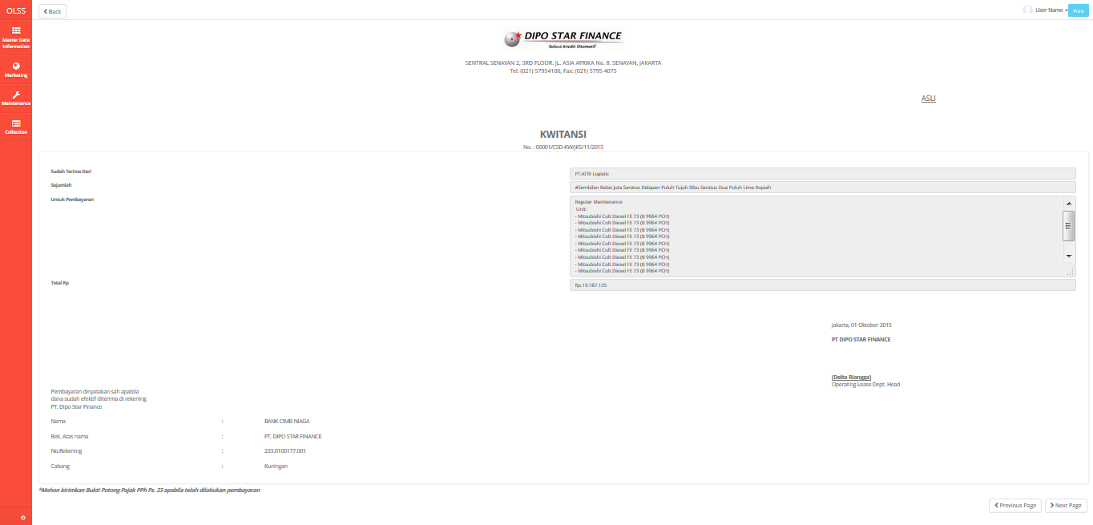

*Screen 12. Maintenance Receipt*

* *Screen Design of Print View Receive Letter*

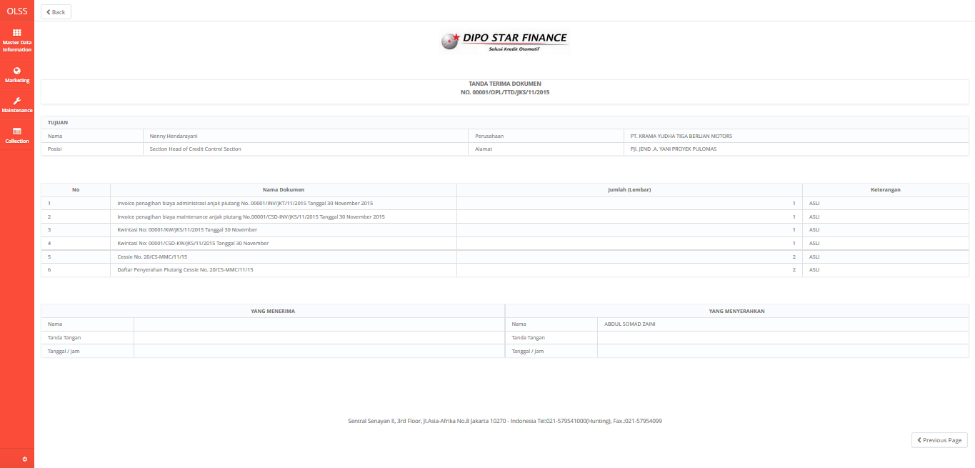

*Screen 13. Receive Letter*

* *Notification: Success! Your data Agreement Number: xxx has been saved after click on button Save as Draft, Save Changes, Submit, Check, Revise, Approve and Reject Billing & Payment History Inquiry*

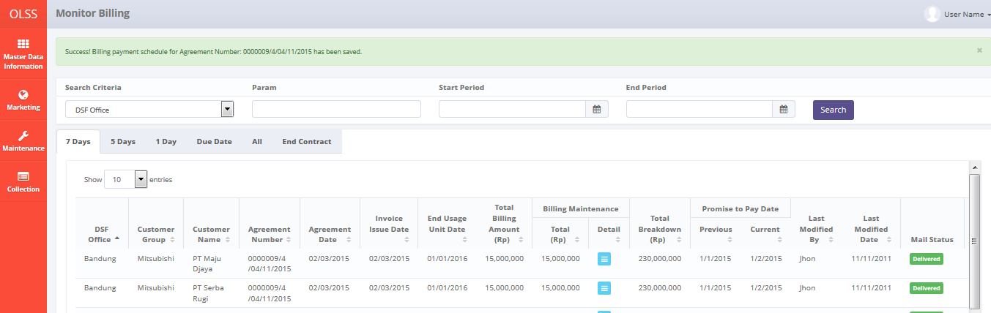

* *Notification: Success! Your data Agreement Number: xxx has been saved after click on button Save as Draft, Save Changes, Submit, Check, Revise, Approve and Reject Invoice*

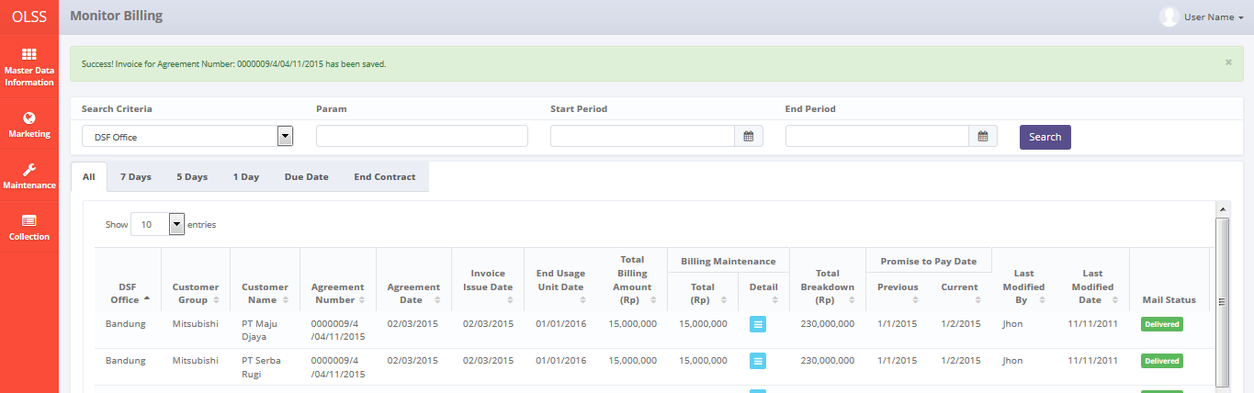

* *Confirmation Pop Up Screen after click on button Save as Draft Billing & Payment History Inquiry and Invoice*

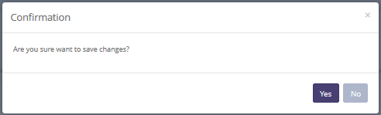

* 1. Component Screen Functionality

1. **View Billing & Payment History Inquiry**

Here are the screen functions from each component in **Screen 1. View Billing & Payment History Inquiry**:

|  |  |  |  |
| --- | --- | --- | --- |
| ***No*** | ***Component*** | ***Name*** | ***Function*** |
| **Header** | | | |
| 1 | Label | Billing & Payment History Inquiry | Billing & Payment Title |
| 2 | Button | Back | Back to previous screen |
| **Contract Information** | | | |
| 3 | Text Field | Agreement Number | To select agreement number |
| 4 | Text Field | Previous Agreement Number | To input previous agreement number |
| 5 | Date Picker | Agreement Date | To input agreement date |
| **Billing and Payment History** | | | |
| 6 | Text Field | Sales PIC Name | To input sales PIC name |
| 7 | Text Field | Sales PIC Position | To input sales PIC position |
| 8 | Text Field | Sales PIC Phone | To input sales PIC phone |
| 9 | Text Field | Sales PIC Email | To input sales PIC email |
| 10 | Text Field | Customer Name | To input customer name |
| 11 | Text Field | Product Brand Name | To input product brand name |
| 12 | Text Field | Product Model Name | To Product model name |
| 13 | Text Field | Model Year | To input model year |
| 14 | Text Field | Lease Category | To input lease category |
| 15 | Text Field | Maintenance Type | To input maintenance type |
| 16 | Text Field | Insurance | To input insurance |
| 17 | Text Field | Purchase Required | To input purchase required |
| 18 | Date Picker | Contract Start Date | To input contract start date |
| 19 | Date Picker | Contract Expired Date | To input contract expired date |
| 20 | Text Field | Lease Period | To input lease period |
| 21 | Text Field | Usage | To input usage place |
| 22 | Text Field | Expectation Collection Amount | To input expectation collection amount |
| 23 | Text Field | Collection Amount | To input collection amount |
| 24 | Text Field | Total Billing | To input total billing |
| 25 | Button | Add | To add new payment history detail (for partial payment) |
| **Billing Schedule List** | | | |
| 26 | Label | Payment Schedule | Display payment schedule |
| 27 | Label | Bill Amount | Display billing amount |
| 28 | Label | Invoice Issue Date | Display invoice issue date |
| 29 | Label | Collection Date | Display collection date |
| 30 | Label | Collection Amount | Display collection amount |
| 31 | Label | Breakdown | Display breakdown amount |
| 32 | Label | Penalty | Display penalty amount |
| 33 | Label | Overdue (Days) | Display overdue (on days) |
| 34 | Label | VAT (10%) | Display VAT (10% of collection billing amount) |
| 35 | Label | PPH (2%) | Display PPH (2% OF collection billing amount) |
| 36 | Label | Action | Display action on list data |
| 37 | Button | Payment Detail | To go to screen Billing & Payment Inquiry Detail |

1. **Edit Billing & Payment History Inquiry**

Here are the screen functions from each component in **Screen 2. Edit Billing & Payment History Inquiry**:

|  |  |  |  |
| --- | --- | --- | --- |
| ***No*** | ***Component*** | ***Name*** | ***Function*** |
| **Header** | | | |
| 1 | Label | Billing & Payment History Inquiry | Edit Billing & Payment Title |
| 2 | Button | Back | Back to previous screen |
| **Agreements Data** | | | |
| 3 | Text Field | Agreement Number | To input agreement number |
| 4 | Text Field | Previous Agreement Number | To input previous agreement number |
| 5 | Date Picker | Agreement Date | To input agreement date |
| **Billing and Payment History** | | | | |
| 6 | Text Field | Sales PIC Name | To input sales PIC name |
| 7 | Text Field | Sales PIC Position | To input sales PIC position |
| 8 | Text Field | Sales PIC Phone | To input sales PIC phone |
| 9 | Text Field | Sales PIC Email | To input sales PIC email |
| 10 | Text Field | Customer Name | To input customer name |
| 11 | Text Field | Product Brand Name | To input product brand name |
| 12 | Text Field | Product Model Name | To Product model name |
| 13 | Text Field | Model Year | To input model year |
| 14 | Text Field | Lease Category | To input lease category |
| 15 | Text Field | Maintenance Type | To input maintenance type |
| 16 | Text Field | Insurance | To input insurance |
| 17 | Text Field | Purchase Required | To input purchase required |
| 18 | Date Picker | Contract Start Date | To input contract start date |
| 19 | Date Picker | Contract Expired Date | To input contract expired date |
| 20 | Text Field | Lease Period | To input lease period |
| 21 | Text Field | Usage | To input usage place |
| 22 | Text Field | Expectation Collection Amount | To input expectation collection amount |
| 23 | Text Field | Collection Amount | To input collection amount |
| 24 | Text Field | Overdue Amount | To input overdue amount |
| 25 | Check Box | Approval Adjustment Memo | To input approval adjustment memo status by checking the checkbox |
| 26 | Text Field | Approval Adjustment Memo | To input approval adjustment memo amount |
| 27 | Drop Down Box | Include PPh | To input include PPh option |
| 28 | Text Field | Billing Total | To input billing total |
| 29 | Check Box | Special Invoice Issue Date | To choose whether invoice issue date can be adjusted |
| 30 | Date Picker | Special Invoice Issue Date | To select the date of invoice issue date |
| **Footer** | | | |
| 31 | Button | Save Changes | To save the changes form |
| 32 | Button | Submit | To submit change data |

1. **Add Billing & Payment History Detail**

Here are the screen functions from each component in **Screen 3. Add Billing & Payment History Detail**:

|  |  |  |  |
| --- | --- | --- | --- |
| ***No*** | ***Component*** | ***Name*** | ***Function*** |
| **Header** | | | |
| 1 | Label | Billing & Payment History Detail | Billing & Payment History Detail Title |
| 2 | Button | Back | Back to previous screen |
| **Agreements Data** | | | |
| 3 | Text Field | Agreement Number | To select agreement number |
| 4 | Text Field | Previous Agreement Number | To input previous agreement number |
| 5 | Date Picker | Agreement Date | To input agreement date |
| **Billing and Payment History Detail** | | | |
| 6 | Drop Down Box | Payment Transaction | To input payment transaction type |
| 7 | Date Picker | First Due Date of Usage Unit | To input first due date of usage unit |
| 8 | Date Picker | First Due Date of Payment | To input first due date of payment |
| 9 | Text Field | Term of Payment (Days) | To input term of payment on days |
| 10 | Text Field | Monthly Instalment | To input monthly instalment amount |
| 11 | Text Field | Deposit Amount | To input deposit amount |
| 12 | Text Field | Number of Payment | To input number of payment |
| 13 | Date Picker | Deposit Payment Date | To input deposit payment date |
| 14 | Date Picker | Deposit Return Date | To input deposit return date |
| 15 | Drop Down Box | Breakdown Special Contract | To input breakdown special contract |
| 16 | Date Picker | Issue of Invoice Date | To input issue if invoice date |
| 17 | Text Field | Interest Penalty (%) | To input interest penalty on (%) |
| 18 | Date Picker | Collection Date | To input collection date |
| 19 | Text Field | Collection Amount | To input collection amount |
| 20 | Drop Down Box | Collection Category | To input collection category |
| 21 | Text Field | Breakdown Amount | To input breakdown amount |
| 22 | Text Field | Penalty Amount | To input penalty amount |
| 23 | Button | Save as Draft | To save as draft all the changes in payment detail |
| 24 | Button | Submit | To submit the modification data |

1. **Edit Billing & Payment Detail**

Here are the screen functions from each component in **Screen 4. Edit Billing & Payment History Detail**:

|  |  |  |  |
| --- | --- | --- | --- |
| ***No*** | ***Component*** | ***Name*** | ***Function*** |
| **Header** | | | |
| 1 | Label | Billing & Payment History Detail | Billing & Payment History Detail Title |
| 2 | Button | Back | Back to previous screen |
| **Agreements Data** | | | |
| 3 | Text Field | Agreement Number | To select agreement number |
| 4 | Text Field | Previous Agreement Number | To input previous agreement number |
| 5 | Date Picker | Agreement Date | To input agreement date |
| **Billing and Payment History Detail** | | | |
| 6 | Drop Down Box | Payment Transaction | To input payment transaction type |
| 7 | Date Picker | First Due Date of Usage Unit | To input first due date of usage unit |
| 8 | Date Picker | First Due Date of Payment | To input first due date of payment |
| 9 | Text Field | Term of Payment (Days) | To input term of payment on days |
| 10 | Text Field | Monthly Instalment | To input monthly instalment amount |
| 11 | Text Field | Deposit Amount | To input deposit amount |
| 12 | Text Field | Number of Payment | To input number of payment |
| 13 | Date Picker | Deposit Payment Date | To input deposit payment date |
| 14 | Date Picker | Deposit Return Date | To input deposit return date |
| 15 | Drop Down Box | Breakdown Special Contract | To input breakdown special contract |
| 16 | Date Picker | Issue of Invoice Date | To input issue if invoice date |
| 17 | Text Field | Interest Penalty (%) | To input interest penalty on (%) |
| 18 | Date Picker | Collection Date | To input collection date |
| 19 | Text Field | Collection Amount | To input collection amount |
| 20 | Drop Down Box | Collection Category | To input collection category |
| 21 | Text Field | Breakdown Amount | To input breakdown amount |
| 22 | Text Field | Penalty Amount | To input penalty amount |
| 23 | Button | Save Changes | To save all the changes in payment detail |
| 24 | Button | Submit | To submit the modification data |

1. **List of Invoice Status Approval**

Here are the screen functions from each component in **Screen 6. List of Invoice Status Approval**:

|  |  |  |  |
| --- | --- | --- | --- |
| ***No*** | ***Component*** | ***Name*** | ***Function*** |
| **Header** | | | |
| 1 | Label | Billing & Payment Invoice Approval Path | Billing & Payment Invoice Approval Path Title |
| 2 | Button | Back | Back to previous screen |
| **Agreements Data** | | | |
| 3 | Text Field | Agreement Number | To select agreement number |
| 4 | Text Field | Previous Agreement Number | To input previous agreement number |
| 5 | Date Picker | Agreement Date | To input agreement date |
| **Billing and Payment History** | | | |
| 6 | Text Field | Sales PIC Name | To view sales PIC name |
| 7 | Text Field | Sales PIC Position | To view sales PIC position |
| 8 | Text Field | Sales PIC Phone | To view sales PIC phone |
| 9 | Text Field | Sales PIC Email | To view sales PIC email |
| 10 | Text Field | Customer Name | To view customer name |
| 11 | Text Field | Product Brand Name | To view product brand name |
| 12 | Text Field | Product Model Name | To view product model name |
| 13 | Text Field | Model Year | To view product model year |
| 14 | Text Field | Lease Category | To view lease category |
| 15 | Text Field | Maintenance Type | To view maintenance type of unit |
| 16 | Text Field | Insurance | To view insurance of unit |
| 17 | Text Field | Purchase Required | To view purchase required |
| 18 | Date Picker | Contract Start Date | To view contract/agreement start date |
| 19 | Date Picker | Contract Expired Date | To view contract/agreement expired date |
| 20 | Text Field | Lease Period (Month) | To view lease period in month |
| 21 | Text Field | Usage | To view usage of unit on contract/agreement |
| 22 | Text Field | Expectation Collection Amount | To view expectation collection amount |
| 23 | Text Field | Billing Total | To view billing total of contract/agreement |
| 24 | Drop Down Box | Include PPh | To view the option of include PPh |
| 25 | Text Field | Billed Breakdown Amount | To view billed breakdown amount |
| **Search Criteria** | | | |
| 26 | Drop down Box | Search Criteria | To select category for searching invoice data |
| 27 | Text Field | Parameter | To input parameter for searching invoice data |
| 28 | Date Picker | Start Invoice Created Date | To input start period based on issue date of invoice |
| 29 | Date Picker | End Invoice Created Date | To input end period based on issue date of invoice |
| 30 | Button | Search | To search invoice data based on selected criteria |
| **Invoice Status Approval List** | | | |
| 31 | Label | DSF Office | To display DSF Office Branch |
| 32 | Label | Invoice No | To display invoice number |
| 33 | Label | Receipt No | To display receipt number |
| 34 | Label | Maintenance Invoice No | To display maintenance invoice number |
| 35 | Label | Maintenance Receipt No | To display maintenance receipt number |
| 36 | Label | Invoice Status | To display latest invoice status |
| 37 | Label | Last Modified Date | To display name of user who check the invoice document |
| 38 | Label | Last Modified By | To display name of user who approve the invoice document |
| 39 | Label | Action | To display action button |
| 40 | Button | Edit Invoice | To edit invoice data |
| 41 | Button | Print Invoice | To print invoice document |
| 42 | Button | View Invoice Status | To submit/check/approve invoice status |

1. **Create Invoice**

Here are the screen functions from each component in **Screen 5. Create Invoice**:

|  |  |  |  |
| --- | --- | --- | --- |
| ***No*** | ***Component*** | ***Name*** | ***Function*** |
| **Header** | | | |
| 1 | Label | Create Invoice | Create Invoice Title |
| 2 | Button | Back | Back to previous screen |
| **Agreements Data** | | | |
| 3 | Text Field | Number Period | To select agreement number |
| 4 | Text Field | Due Date | To input previous agreement number |
| 5 | Text Field | Usage Period | To input agreement date |
| 6 | Text Field | Customer Group | To input customer group |
| 7 | Text Field | Agreement No | To input agreement number |
| 8 | Text Field | Lessee Name | To input customer name |
| 9 | Text Field | Lessee NPWP | To input customer NPWP |
| 10 | Text Field | Lessee Address | To input customer address |
| 11 | Label | Instalment Amount | To input instalment amount |
| 12 | Label | Breakdown Amount | To input breakdown amount |
| 13 | Label | Instalment + Breakdown | To input instalment + breakdown amount |
| 14 | Label | Police Number | To input police number of the unit |
| 15 | Label | Object Type | To input object type |
| 16 | Label | Description | To input description of maintenance |
| 17 | Label | Maintenance Amount | To input maintenance amount |
| 18 | Button | Save and Print | To save invoice data and print preview of invoice |

1. **View Invoice Status Approval**

Here are the screen functions from each component in **Screen 7. Invoice Status Approval**:

|  |  |  |  |
| --- | --- | --- | --- |
| ***No*** | ***Component*** | ***Name*** | ***Function*** |
| **Header** | | | |
| 1 | Label | Create Invoice | Create Invoice Title |
| 2 | Button | Back | Back to previous screen |
| **Agreements Data** | | | |
| 3 | Text Field | Number Period | To select agreement number |
| 4 | Text Field | Due Date | To input previous agreement number |
| 5 | Text Field | Usage Period | To input agreement date |
| 6 | Text Field | Customer Group | To input customer group |
| 7 | Text Field | Agreement No | To input agreement number |
| 8 | Text Field | Lessee Name | To input customer name |
| 9 | Text Field | Lessee NPWP | To input customer NPWP |
| 10 | Text Field | Lessee Address | To input customer address |
| 11 | Label | Instalment Amount | To input instalment amount |
| 12 | Label | Breakdown Amount | To input breakdown amount |
| 13 | Label | Instalment + Breakdown | To input instalment + breakdown amount |
| 14 | Label | Police Number | To input police number of the unit |
| 15 | Label | Object Type | To input object type |
| 16 | Label | Description | To input description of maintenance |
| 17 | Label | Maintenance Amount | To input maintenance amount |
| 18 | Text Field | Remarks | To input comment when click REJECT or REVISE button |
| 19 | Button | Check | To change the status of document to CHECKED, means this document already checked by authorize user |
| 20 | Button | Approve | To change the status of document to APPROVED, means this document already approved by authorize user |
| 21 | Button | Reject | To change the status of document to REJECTED, means this document already rejected by authorize user |
| 22 | Button | Revise | To change the status of document to REVISED, means this document need to be revised by authorize user |

1. **Edit Delivery Invoice**

Here are the screen functions from each component in **Screen 8. Edit Delivery Invoice**:

|  |  |  |  |
| --- | --- | --- | --- |
| ***No*** | ***Component*** | ***Name*** | ***Function*** |
| **Header** | | | |
| 1 | Label | Create Invoice | Create Invoice Title |
| 2 | Button | Back | Back to previous screen |
| **Agreements Data** | | | |
| 3 | Text Field | Number Period | To select agreement number |
| 4 | Text Field | Due Date | To input previous agreement number |
| 5 | Text Field | Usage Period | To input agreement date |
| 6 | Text Field | Customer Group | To input customer group |
| 7 | Text Field | Agreement No | To input agreement number |
| 8 | Text Field | Lessee Name | To input customer name |
| 9 | Text Field | Lessee NPWP | To input customer NPWP |
| 10 | Text Field | Lessee Address | To input customer address |
| 11 | Label | Instalment Amount | To input instalment amount |
| 12 | Label | Breakdown Amount | To input breakdown amount |
| 13 | Label | Instalment + Breakdown | To input instalment + breakdown amount |
| 14 | Label | Police Number | To input police number of the unit |
| 15 | Label | Object Type | To input object type |
| 16 | Label | Description | To input description of maintenance |
| 17 | Label | Maintenance Amount | To input maintenance amount |
| 18 | Date Picker | Delivery Date | To input the date when invoice actually delivered |
| 19 | Drop Down Box | Delivery By | To input type of delivery by, internal courier or courier agent |
| 20 | Text Field | Registration No | To input the registration number if delivery invoice conducted by Courier Agent |
| 21 | Button | Save Changes | To save changes data |
| 22 | Button | Submit | To submit all changes data |

* 1. Operation Description

|  |  |  |
| --- | --- | --- |
| **No.** | **Operation Name** | **Description** |
| 1 | Initial view of Billing & Payment History Inquiry | The screen of payment history inquiry:   1. Component Status;  |  |  |  |  | | --- | --- | --- | --- | | Component | Name/Caption | Status | Remark | | Drop down box | User Name | Active |  | | Label | Billing & Payment History Inquiry | Not Active |  | | Button | Back | Active |  | | Button | Edit Billing | Active |  | | Text Field | Agreement Number | Not Active |  | | Text Field | Previous Agreement Number | Not Active |  | | Text Field | Agreement Date | Not Active |  | | Text Field | Sales PIC Name | Not Active |  | | Text Field | Sales PIC Position | Not Active |  | | Text Field | Sales PIC Phone | Not Active |  | | Text Field | Sales PIC Email | Not Active |  | | Text Field | Customer Name | Not Active |  | | Text Field | Product Brand Name | Not Active |  | | Text Field | Product Model Name | Not Active |  | | Text Field | Model Year | Not Active |  | | Text Field | Lease Category | Not Active |  | | Text Field | Maintenance Type | Not Active |  | | Text Field | Insurance | Not Active |  | | Text Field | Purchase Required | Not Active |  | | Text Field | Contract Start Date | Not Active |  | | Text Field | Contract Expired Date | Not Active |  | | Text Field | Lease Period | Not Active |  | | Text Field | Usage | Not Active |  | | Text Field | Expectation Collection Amount | Not Active |  | | Text Field | Overdue Amount | Not Active |  | | Text Field | Billing Total | Not Active |  | | Button | Add | Active |  | | Label | Payment Schedule | Not Active |  | | Label | Invoice Issue Date | Not Active |  | | Label | Collection Date | Not Active |  | | Label | Collection Amount | Not Active |  | | Label | Breakdown | Not Active |  | | Label | Penalty | Not Active |  | | Label | Overdue (Days) | Not Active |  | | Label | VAT (10%) | Not Active |  | | Label | PPH (2%) | Not Active |  | | Label | Overdue (Days) | Not Active |  | | Label | Action | Not Active |  | | Button | Edit Payment Detail | Active |  | |
| 2 | View Billing & Payment History Inquiry | Input:   1. Access OLSS 2. Select menu Billing Collection 3. Select sub menu Monitor Schedule 4. Click button view billing on the List of Agreement Due Date Tab     Process:   1. When user click button view billing, system will display **Screen 1. View Billing & Payment History Inquiry** 2. Billing data which will be displayed depend on the clicked button on row of agreement data in monitor schedule 3. System will search data on table TB_BIL_PaySchedule join with OPLAgreement 4. List payment schedule will display according tenor of billing agreement, on table TB_BIL_PayScheduleDetail 5. List payment schedule will be sorted by PaymentSchedulle ascending   Alternative:  N/A |
| 3 | Initial view of Edit Billing & Payment History Inquiry | The screen of payment history inquiry:   1. Component Status;  |  |  |  |  | | --- | --- | --- | --- | | Component | Name/Caption | Status | Remark | | Drop down box | User Name | Active |  | | Label | Billing & Payment History Inquiry | Not Active |  | | Button | Back | Active |  | | Button | Edit Billing | Active |  | | Text Field | Agreement Number | Not Active |  | | Text Field | Previous Agreement Number | Not Active |  | | Text Field | Agreement Date | Not Active |  | | Text Field | Sales PIC Name | Not Active |  | | Text Field | Sales PIC Position | Not Active |  | | Text Field | Sales PIC Phone | Not Active |  | | Text Field | Sales PIC Email | Not Active |  | | Text Field | Customer Name | Not Active |  | | Text Field | Product Brand Name | Not Active |  | | Text Field | Product Model Name | Not Active |  | | Text Field | Model Year | Not Active |  | | Text Field | Lease Category | Not Active |  | | Text Field | Maintenance Type | Not Active |  | | Text Field | Insurance | Not Active |  | | Text Field | Purchase Required | Not Active |  | | Text Field | Contract Start Date | Not Active |  | | Text Field | Contract Expired Date | Not Active |  | | Text Field | Lease Period | Not Active |  | | Text Field | Usage | Not Active |  | | Text Field | Expectation Collection Amount | Not Active |  | | Text Field | Overdue Amount | Not Active |  | | Checkbox | Approval Adjustment Memo | Active |  | | Text Field | Adjustment Breakdown Amount | Active when approval adjustment memo checked |  | | Dropdown | Include Pph | Active |  | | Checkbox | Special Invoice Issue Date | Active |  | | Datepicker | Special Invoice Issue Date | Active when special invoice issue date checked |  | | Text Field | Billing Total | Not Active |  | | Button | Save Change | Active |  | | Button | Submit | Active |  | |
| 4 | Edit Billing & Payment History Inquiry | Input:   1. Operation Name *2. View Billing & Payment History Inquiry 1-4* 2. Click button Edit billing on **Screen 1. View Billing & Payment History Inquiry** 3. Base on **Screen 2. Edit Billing & Payment History Inquiry**, Update the following field(s) if needed:  |  |  | | --- | --- | | **Billing & Payment Data** | **Constraint Input** | | Approval Adjustoment Memo | Varchar | | Adjustment Breakdown Amount | Varchar | | Include Pph | Varchar | | Special Invoice Issue Date | Datetime |   Constraint:   * 1. If approval adjustment memo checked, then breakdown adjustment amount textbox will active and required   2. If approval adjustment memo unchecked, then breakdown adjustment amount textbox will not active   3. If special invoice issue date checked, then date of issue date active and required  1. Click on button Save Changes on the bottom-left on the screen     Constraint:   * 1. Clicking the button will trigger a pop up screen for validation “**Are you sure you want to save all changes?**”  1. Click on button Submit on the bottom-left on the screen     Constraint:   1. Clicking the button will trigger a pop up screen for validation “**Are you sure you want to submit data?**”   Process:   1. After confirmed, updated data will save to table TB_BIL_PaySchedule and TB_BIL_PayScheduleDtl 2. When Save Changes button is clicked, system will add a new log of:   Payment Schedule action to TB_BIL_PaySchedule_History. Data which should be inserted are:   |  |  | | --- | --- | | **Field Name** | **Value** | | ProcessId | New GUID | | OriginalId | TB_BIL_PaySchedule | | CreatedDate | Sys.CurrentDate | | CreatedBy | User.UserName | | Action | TB_OPL_Status.StatusCode = DRAFT |   Also will insert all updated fields on table TB_BIL_PaySchedule to table TB_BIL_PaySchedule_History_Dtl  And new log of Payment Schedule Detail action to TB_BIL_PayScheduleDtl_History. Data which should be inserted are:   |  |  | | --- | --- | | **Field Name** | **Value** | | ProcessId | New GUID | | OriginalId | TB_BIL_PayScheduleDtl | | CreatedDate | Sys.CurrentDate | | CreatedBy | User.UserName | | Action | TB_OPL_Status.StatusCode = DRAFT |   Also will insert all updated fields on table TB_BIL_PayScheduleDtl to table TB_BIL_PayScheduleDtl_History_Dtl   1. When Submit button is clicked, System will add a new log of Payment Schedule action to TB_BIL_PaySchedule_History. Data which should be inserted are:  |  |  | | --- | --- | | **Field Name** | **Value** | | ProcessId | New GUID | | OriginalId | TB_BIL_PaySchedule | | CreatedDate | Sys.CurrentDate | | CreatedBy | User.UserName | | Action | TB_OPL_Status.StatusCode = SUBMITTED |   Also will insert all updated fields on table TB_BIL_PaySchedule to table TB_BIL_PaySchedule_History_Dtl  And new log of Payment Schedule Detail action to TB_BIL_PayScheduleDtl_History. Data which should be inserted are:   |  |  | | --- | --- | | **Field Name** | **Value** | | ProcessId | New GUID | | OriginalId | TB_BIL_PayScheduleDtl | | CreatedDate | Sys.CurrentDate | | CreatedBy | User.UserName | | Action | TB_OPL_Status.StatusCode = SUBMITTED |   Also will insert all updated fields on table TB_BIL_PayScheduleDtl to table TB_BIL_PayScheduleDtl_History_Dtl  Output:   1. The row of edited Billing & Payment History Inquiry data at Monitor Schedule screen will be change. 2. Display success message on top of Monitor Schedule when Billing & Payment History Inquiry data has been submitted or save changes successfully:   “Success! Billing data for Agreement Number: 000001/04/11/2015 has been successfully updated/submitted”  Alternative:   1. From step 1, click on Back button to go back to previous screen (list of agreement on tab 7 Days) |
| 5 | Initial view of Update Payment Billing | The screen of update payment billing:   1. Component Status;  |  |  |  |  | | --- | --- | --- | --- | | Component | Name/Caption | Status | Remark | | Drop down box | User Name | Active |  | | Label | Billing & Payment History Detail | Not Active |  | | Button | Back | Active |  | | Text Field | Agreement Number | Not Active |  | | Text Field | Previous Agreement Number | Not Active |  | | Text Field | Agreement Date | Not Active |  | | Drop Down Box | Payment Transaction | Active |  | | Text Field | First due date of Usage Unit | Not Active |  | | Text Field | First due date of payment | Not Active |  | | Text Field | Term of Payment | Active |  | | Text Field | Monthly instalment | Active |  | | Text Field | Deposit amount | Active |  | | Text Field | Number of Payment | Active |  | | Text Field | Deposit Payment date | Not Active |  | | Text Field | Deposit return date | Not Active |  | | Drop Down Box | Breakdown Special contract | Active |  | | Text Field | Issue of invoice date | Not Active |  | | Text Field | Interest penalty (%) | Active |  | | Text Field | Collection Date | Not Active |  | | Text Field | Collection Amount | Active |  | | Drop Down Box | Collection Category | Active |  | | Text Field | Breakdown Amount | Active |  | | Text Field | Penalty Amount | Active |  | | Button | Save Changes | Active |  | | Button | Submit | Active |  | |
| 6 | Add Billing & Payment History Detail | Input:   1. Operation Name *2. View Billing & Payment History Inquiry 1-4* 2. Click on button Add Payment      1. On Payment Schedule, click button  to select on which payment schedule will add new payment data 2. Base on **Screen 3. Add Billing & Payment History Detail**, Insert the following field(s) if needed:  |  |  | | --- | --- | | **Billing & Payment Detail** | **Constraint Input** | | Payment Transaction | Varchar | | Breakdown Special Contract | Decimal(18,3) | | Issue of Invoice Date | Datetime | | Interest Penalty (%) | Decimal(18,6) | | Giro Number | Varchar | | Collection Date | Datetime | | Collection Amount | Decimal(18,3) | | Collection Category | Varchar | | Penalty Amount | Decimal(18,3) | | Breakdown Amount | Decimal(18,3) |   Constraint:   1. Default value of Payment Transaction: Transfer 2. If Payment Transaction is Transfer, then Giro Number will be not displayed 3. Collection date will set when the date of payment transaction 4. Payment transaction will be optioned by Transfer or Giro 5. If payment transaction set Giro, then will display Text Field to input Giro Number 6. Click button Save as Draft     Constraint:   1. Clicking the button will trigger a pop up screen for validation “**Are you sure you want to Save as Draft data payment for Agreement Number: xxxx ?**” 2. Click on button Submit on the bottom-left on the screen     Constraint:   1. Clicking the button will trigger a pop up screen for validation “**Are you sure you want to submit data payment for Agreement Number: xxxx ?**”   Process:   1. After confirmed, updated data will save to table TB_BIL_PaySchedule and TB_BIL_PayScheduleDtl 2. When Save Changes button is clicked, system will add a new log of:   Payment Schedule action to TB_BIL_PaySchedule_History. Data which should be inserted are:   |  |  | | --- | --- | | **Field Name** | **Value** | | ProcessId | New GUID | | OriginalId | TB_BIL_PaySchedule | | CreatedDate | Sys.CurrentDate | | CreatedBy | User.UserName | | Action | TB_OPL_Status.StatusCode = DRAFT |   Also will insert all updated fields on table TB_BIL_PaySchedule to table TB_BIL_PaySchedule_History_Dtl  And new log of Payment Schedule Detail action to TB_BIL_PayScheduleDtl_History. Data which should be inserted are:   |  |  | | --- | --- | | **Field Name** | **Value** | | ProcessId | New GUID | | OriginalId | TB_BIL_PayScheduleDtl | | CreatedDate | Sys.CurrentDate | | CreatedBy | User.UserName | | Action | TB_OPL_Status.StatusCode = DRAFT |   Also will insert all updated fields on table TB_BIL_PayScheduleDtl to table TB_BIL_PayScheduleDtl_History_Dtl   1. When Submit button is clicked, System will add a new log of Payment Schedule action to TB_BIL_PaySchedule_History. Data which should be inserted are:  |  |  | | --- | --- | | **Field Name** | **Value** | | ProcessId | New GUID | | OriginalId | TB_BIL_PaySchedule | | CreatedDate | Sys.CurrentDate | | CreatedBy | User.UserName | | Action | TB_OPL_Status.StatusCode = SUBMITTED |   Also will insert all updated fields on table TB_BIL_PaySchedule to table TB_BIL_PaySchedule_History_Dtl  And new log of Payment Schedule Detail action to TB_BIL_PayScheduleDtl_History. Data which should be inserted are:   |  |  | | --- | --- | | **Field Name** | **Value** | | ProcessId | New GUID | | OriginalId | TB_BIL_PayScheduleDtl | | CreatedDate | Sys.CurrentDate | | CreatedBy | User.UserName | | Action | TB_OPL_Status.StatusCode = SUBMITTED |   Also will insert all updated fields on table TB_BIL_PayScheduleDtl to table TB_BIL_PayScheduleDtl_History_Dtl  Output:   1. The new row of Billing & Payment History Detail data at View Billing & Payment History Inquiry screen will be change. 2. Display success message on top of View Billing & Payment History Inquiry when Billing & Payment History Detail data has been submitted or save as draft successfully:   “Success! Payment data for Agreement Number: 000001/04/11/2015 has been successfully save as draft/submitted”  Alternative:  From step 1, click on Back button to go back to previous screen (Payment History Inquiry screen) |
| 7 | Edit Billing & Payment History Detail | Input:   1. Operation Name *2. View Billing & Payment History Inquiry 1-4* 2. Click on button Update Payment      1. Base on **Screen 4. Update Billing & Payment History Detail**, Update the following field(s) if needed:  |  |  | | --- | --- | | **Billing & Payment Detail** | **Constraint Input** | | Payment Transaction | Varchar | | Breakdown Special Contract | Decimal(18,3) | | Issue of Invoice Date | Datetime | | Interest Penalty (%) | Decimal(18,6) | | Giro Number | Varchar | | Collection Date | Datetime | | Collection Amount | Decimal(18,3) | | Collection Category | Varchar | | Penalty Amount | Decimal(18,3) | | Breakdown Amount | Decimal(18,3) |   Constraint:   1. Default value of Payment Transaction: Transfer 2. If Payment Transaction is Transfer, then Giro Number will be not displayed 3. Collection date will set when the date of payment transaction 4. Payment transaction will be optioned by Transfer or Giro 5. If payment transaction set Giro, then will display Text Field to input Giro Number 6. Click button Save Changes     Constraint:   1. Clicking the button will trigger a pop up screen for validation “**Are you sure you want to save changes data payment for Agreement Number: xxxx ?**” 2. Click on button Submit on the bottom-left on the screen     Constraint:   1. Clicking the button will trigger a pop up screen for validation “**Are you sure you want to submit data payment for Agreement Number: xxxx ?**”   Process:   1. After confirmed, updated data will save to table TB_BIL_PaySchedule and TB_BIL_PayScheduleDtl 2. When Save Changes button is clicked, system will add a new log of:   Payment Schedule action to TB_BIL_PaySchedule_History. Data which should be inserted are:   |  |  | | --- | --- | | **Field Name** | **Value** | | ProcessId | New GUID | | OriginalId | TB_BIL_PaySchedule. TB_BIL_PaySchedule | | CreatedDate | Sys.CurrentDate | | CreatedBy | User.UserName | | Action | TB_OPL_Status.StatusCode = DRAFT |   Also will insert all updated fields on table TB_BIL_PaySchedule to table TB_BIL_PaySchedule_History_Dtl  And new log of Payment Schedule Detail action to TB_BIL_PayScheduleDtl_History. Data which should be inserted are:   |  |  | | --- | --- | | **Field Name** | **Value** | | ProcessId | New GUID | | OriginalId | TB_BIL_PayScheduleDtl.Id TB_BIL_PayScheduleDtl | | CreatedDate | Sys.CurrentDate | | CreatedBy | User.UserName | | Action | TB_OPL_Status.StatusCode = DRAFT |   Also will insert all updated fields on table TB_BIL_PayScheduleDtl to table TB_BIL_PayScheduleDtl_History_Dtl   1. When Submit button is clicked, System will add a new log of Payment Schedule action to TB_BIL_PaySchedule_History. Data which should be inserted are:  |  |  | | --- | --- | | **Field Name** | **Value** | | ProcessId | New GUID | | OriginalId | TB_BIL_PaySchedule. IdTB_BIL_PaySchedule | | CreatedDate | Sys.CurrentDate | | CreatedBy | User.UserName | | Action | TB_OPL_Status.StatusCode = SUBMITTED |   Also will insert all updated fields on table TB_BIL_PaySchedule to table TB_BIL_PaySchedule_History_Dtl  And new log of Payment Schedule Detail action to TB_BIL_PayScheduleDtl_History. Data which should be inserted are:   |  |  | | --- | --- | | **Field Name** | **Value** | | ProcessId | New GUID | | OriginalId | TB_BIL_PayScheduleDtl.Id TB_BIL_PayScheduleDtl | | CreatedDate | Sys.CurrentDate | | CreatedBy | User.UserName | | Action | TB_OPL_Status.StatusCode = SUBMITTED |   Also will insert all updated fields on table TB_BIL_PayScheduleDtl to table TB_BIL_PayScheduleDtl_History_Dtl  Output:   1. The row of edited Billing & Payment History Detail data at View Billing & Payment History Inquiry screen will be change. 2. Display success message on top of View Billing & Payment History Inquiry when Billing & Payment History Detail data has been submitted or save as draft successfully:   “Success! Payment data for Agreement Number: 000001/04/11/2015 has been successfully save as draft/submitted”  Alternative:   1. From step 1, click on Back button to go back to previous screen (Payment History Inquiry screen) |
| 8 | Initial view of Create Invoice | The screen of Create Invoice:   1. Component Status;  |  |  |  |  | | --- | --- | --- | --- | | Component | Name/Caption | Status | Remark | | Drop down box | User Name | Active |  | | Label | Billing & Payment History Inquiry | Not Active |  | | Button | Back | Active |  | | Text Field | Number Period | Not Active |  | | Text Field | Due Date | Not Active |  | | Text Field | Usage Period | Not Active |  | | Text Field | Customer Group | Not Active |  | | Text Field | Agreement Number | Not Active |  | | Text Field | Lessee Name | Not Active |  | | Text Field | Lessee NPWP | Not Active |  | | Text Field | Lessee Address | Not Active |  | | Label | Instalment Amount | Not Active |  | | Label | Breakdown Amount | Not Active |  | | Label | Instalment + Breakdown | Not Active |  | | Label | Police Number | Not Active |  | | Label | Object Type | Not Active |  | | Label | Description | Not Active |  | | Label | Maintenance Amount | Not Active |  | | Button | Save and Print | Active |  | |
| 9 | Create Invoice | Input:   1. Click menu Monitor Billing Schedule 2. On 7 Days tab, click button Create Invoice     Constraint:   1. Only agreements with 7 days before end of usage unit can be created invoice and receipt. 2. Once invoice created, its creates instalment invoice, receipt, maintenance invoice and receipt.   Process:   1. Click on button Save and Print on the bottom-left of the screen     Constraint:   1. Clicking the button will trigger a pop up screen for validation “**Are you sure you want to save and print invoice?**” 2. Clicking the button also will save invoice data and print invoice and receipt, and will automatically send email to customer. 3. For maintenance billing, will automatically retrieve data from table OPLServiceHistory_History_Dtl where IdOPLAgreement = OPLAgreement.IdOPLAgreement 4. When Save and Print button is clicked, system will add a new log of:   Invoice action to TB_BIL_InvoiceReceipt_History. Data which should be inserted are:   |  |  | | --- | --- | | **Field Name** | **Value** | | ProcessId | New GUID | | OriginalId | TB_BIL_InvoiceReceipt | | CreatedDate | Sys.CurrentDate | | CreatedBy | User.UserName | | Action | TB_OPL_Status.StatusCode = DRAFT |   Also will insert all updated fields on table TB_BIL_InvoiceReceipt to table TB_BIL_InvoiceReceipt_History_Dtl   1. When Submit button is clicked, System will add a new log Invoice action to TB_BIL_Invoice_History. Data which should be inserted are:  |  |  | | --- | --- | | **Field Name** | **Value** | | ProcessId | New GUID | | OriginalId | TB_BIL_InvoiceReceipt | | CreatedDate | Sys.CurrentDate | | CreatedBy | User.UserName | | Action | TB_OPL_Status.StatusCode = SUBMITTED |   Also will insert all updated fields on table TB_BIL_InvoiceReceipt to table TB_BIL_InvoiceReceipt_History_Dtl   1. After save data, system will automatically print Invoice and Receipt, contain:  * Installment Invoice * Installment Receipt * Maintenance Invoice * Maintenance Receipt * Receive Letter   Output:   1. The new row of Invoice data at View Billing & Payment History Inquiry screen will be change. 2. Display success message on top of View Billing & Payment History Inquiry when Billing & Payment History Detail data has been submitted or save as draft successfully:   “Success! Invoice Number: 00001/INV/BDG/11/2015 has been successfully saved”   1. Printed documents contain:  * Installment Invoice * Installment Receipt * Maintenance Invoice * Maintenance Receipt * Receive Letter   Alternative:   1. From step 1, click on Back button to go back to previous screen (list of agreement on tab 7 Days) |
| 10 | Initial List of Invoice Status Approval | The screen of List of Status Approval:   1. Component Status;  |  |  |  |  | | --- | --- | --- | --- | | Component | Name/Caption | Status | Remark | | Drop down box | User Name | Active |  | | Label | Billing & Payment Invoice Approval Path | Not Active |  | | Button | Back | Active |  | | Label | DSF Office | Not Active |  | | Label | Invoice No | Not Active |  | | Label | Receipt No | Not Active |  | | Label | Maintenance Invoice No | Not Active |  | | Label | Maintenance Invoice Receipt No | Not Active |  | | Label | Invoice Status | Not Active |  | | Label | Created By | Not Active |  | | Label | Checked By | Not Active |  | | Label | Approved By | Not Active |  | | Label | Action | Not Active |  | | Button | First Page | Active | Active depending on the current entry | | Button | Previous Page | Active | Active depending on the current entry | | Link | Page Number | Active | Active depending on the current entry | | Button | Next Page | Active | Active depending on the current entry | | Button | Last Page | Active | Active depending on the current entry | | Button | Print Invoice | Active |  | | Button | Invoice Status Approval | Active |  | |
| 11 | Searching the List of Invoice Status Approval | Input:   1. Select searching criteria category (search criteria), searching criteria value (param), Start Period (End usage unit date) and End Period (End usage unit date) in search field       Constraint:   1. Search criteria only consists of DSF Office, Invoice No, Receipt No, Maintenance Invoice, Maintenance Receipt No, Invoice Status, Created By, Checked By and Approved By (the same as the lists) generated from Tb_OPL_SearchCriteria mapping 2. End Period can not be less than Start Period (the End Period will be locked for the date before Start Date) 3. Start Period can not be more than End Period (the Start Period will be locked for the date after End Date) 4. Click on the Search Button      1. The screen will view the list of agreement according to criteria 2. Based on **Screen 6. List of Invoice Status Approval**, information related to Invoice that will be display automatically are:  * DSF Office * Invoice No * Receipt No * Maintenance Invoice No * Maintenance Invoice Receipt No * Invoice status * Create By * Checked By * Approved By  1. Number data row on list will be based on selected show number entries 2. Select number of show list entries: 10, 25, 50, and 100 and click the page for viewing more data   Process:   1. Default view will display data list of invoice for selected agreement that already issued 2. After click the Search button, the system will get data from Tb_BIL_InvoiceReceipt table to be displayed in the list   Output:   1. Display list data of invoice |
| 12 | Edit Delivery Invoice | Input:   1. Access OLSS 2. Select menu Billing Collection 3. Select sub menu Monitor Schedule 4. On tab 7 Days, click button View Invoice List      1. On specific row, click button Edit Delivery Invoice to edit delivery invoice      1. Base on **Screen 8. Edit Delivery Invoice**, Update the following field if needed:  |  |  | | --- | --- | | **Invoice Data** | **Constraint Input** | | Delivery Date | Datetime | | Delivery By | Dropdown | | Registration Number | Varchar |   Constraint:   1. Default value for Delivery By is “Internal Courier” 2. If Delivery By is “Internal Courier”, then Registration Number is not visible 3. If Deliver By is “Courier Agent”, then Registration Number is visible and required 4. Click on button Save Changes on the bottom-left on the screen     Constraint:   * 1. Clicking the button will trigger a pop up screen for validation “**Are you sure you want to save all changes?**”  1. Click on button Submit on the bottom-left on the screen     Constraint:   1. Clicking the button will trigger a pop up screen for validation “**Are you sure you want to submit data?**”   Process:   1. After confirmed, updated data will save to table TB_BIL_InvoiceReceipt 2. When Save Changes button is clicked, system will add a new log of:   Invoice action to TB_BIL_InvoiceReceipt_History. Data which should be inserted are:   |  |  | | --- | --- | | **Field Name** | **Value** | | ProcessId | New GUID | | OriginalId | TB_BIL_InvoiceReceipt.IdTB_BIL_InvoiceReceipt | | CreatedDate | Sys.CurrentDate | | CreatedBy | User.UserName | | Action | TB_OPL_Status.StatusCode = DRAFT |   Also will insert all updated fields on table TB_BIL_InvoiceReceipt to table TB_BIL_InvoiceReceipt_History_Dtl  Output:   1. The row of edited Invoice data at List of Invoice screen will be change. 2. Invoice Status set “DELIVERED” 3. Display success message on top of Monitor Schedule when Billing & Payment History Inquiry data has been submitted or save changes successfully:   “Success! Delivery invoice for Invoice Number: 000001/INV/BDG/11/2015 has been successfully updated/submitted”  Alternative:   1. From step 1, click on Back button to go back to previous screen (list of agreement on tab 7 Days) |
| 13 | Invoice Approval Process | Input:   1. Access OLSS 2. Select menu Billing Collection 3. Select sub menu Monitor Schedule 4. On tab 7 Days, click button View Invoice List      1. On specific row, click button Edit Delivery Invoice to View Invoice Approval   Constraint:   1. User can only select one Invoice to be viewed at once 2. Base on Screen **7. Invoice Status Approval**, update the following field if needed:  |  |  | | --- | --- | | **Invoice Approval** | **Constraint Input** | | Remarks | Text Area |   Approval Process:   * **Revise**  1. Click Revise button      1. Confirmation dialog with ‘Are you sure you want to Revise?’. Message will be displayed after user click Revise button   Constraint:   1. Validation and revise process will be executed after user click Yes button at confirmation dialog. 2. When Revise button is clicked, system will:  * Set value at TB_BIL_InvoiceReceipt.InvoiceStatus = REVISED * Add a new Log of Invoice action to TB_BIL_InvoiceReceipt_History. Data which should be inserted are: User Name, Date and Status (Tb_OPL_Status.StatusName = REVISED)  |  |  | | --- | --- | | **Field Name** | **Value** | | ProcessId | New GUID | | OriginalId | TB_BIL_InvoiceReceipt.IdTB_BIL_InvoiceReceipt | | CreatedDate | Sys.CurrentDate | | CreatedBy | User.UserName | | Action | TB_OPL_Status.StatusCode = REVISED |   Also will insert all updated fields on table TB_BIL_InvoiceReceipt to table TB_BIL_InvoiceReceipt_History_Dtl   1. Will display success notification and data has been updated successfully  * **Check**  1. Click Check button      1. Confirmation dialog with ‘Are you sure you want to Check?’. Message will be displayed after user click Check button   Constraint:   1. Validation and check process will be executed after user click Yes button at confirmation dialog. 2. When Check button is clicked, system will:  * Set value at TB_BIL_InvoiceReceipt.InvoiceStatus = CHECKED * Add a new Log of Invoice action to TB_BIL_InvoiceReceipt_History. Data which should be inserted are: User Name, Date and Status (Tb_OPL_Status.StatusName = CHECKED)  |  |  | | --- | --- | | **Field Name** | **Value** | | ProcessId | New GUID | | OriginalId | TB_BIL_InvoiceReceipt.IdTB_BIL_InvoiceReceipt | | CreatedDate | Sys.CurrentDate | | CreatedBy | User.UserName | | Action | TB_OPL_Status.StatusCode = CHECKED |   Also will insert all updated fields on table TB_BIL_InvoiceReceipt to table TB_BIL_InvoiceReceipt_History_Dtl   1. Will display success notification and data has been updated successfully  * **Reject**  1. Click Reject button      1. Confirmation dialog with ‘Are you sure you want to Reject?’. Message will be displayed after user click Reject button   Constraint:   1. Validation and reject process will be executed after user click Yes button at confirmation dialog. 2. When Reject button is clicked, system will:  * Set value at TB_BIL_InvoiceReceipt.InvoiceStatus = REJECTED * Add a new Log of Invoice action to TB_BIL_InvoiceReceipt_History. Data which should be inserted are: User Name, Date and Status (Tb_OPL_Status.StatusName = REJECTED)  |  |  | | --- | --- | | **Field Name** | **Value** | | ProcessId | New GUID | | OriginalId | TB_BIL_InvoiceReceipt.IdTB_BIL_InvoiceReceipt | | CreatedDate | Sys.CurrentDate | | CreatedBy | User.UserName | | Action | TB_OPL_Status.StatusCode = REJECTED |   Also will insert all updated fields on table TB_BIL_InvoiceReceipt to table TB_BIL_InvoiceReceipt_History_Dtl   1. Will display success notification and data has been updated successfully  * **Approve**  1. Click Approve button      1. Confirmation dialog with ‘Are you sure you want to Approve?’. Message will be displayed after user click Approve button   Constraint:   1. Validation and approve process will be executed after user click Yes button at confirmation dialog. 2. When Approve button is clicked, system will:  * Set value at TB_BIL_InvoiceReceipt.InvoiceStatus = APPROVED * Add a new Log of Invoice action to TB_BIL_InvoiceReceipt_History. Data which should be inserted are: User Name, Date and Status (Tb_OPL_Status.StatusName = APPROVED)  |  |  | | --- | --- | | **Field Name** | **Value** | | ProcessId | New GUID | | OriginalId | TB_BIL_InvoiceReceipt.IdTB_BIL_InvoiceReceipt | | CreatedDate | Sys.CurrentDate | | CreatedBy | User.UserName | | Action | TB_OPL_Status.StatusCode = APPROVED |   Also will insert all updated fields on table TB_BIL_InvoiceReceipt to table TB_BIL_InvoiceReceipt_History_Dtl  Will display success notification and data has been updated successfully  Alternative:  N/A |
| 14 | Print Report Invoice Historical | Input:   1. *Operation Name 3. Search Invoice Data* 2. Click button Print Report   Process:   1. *Operation Name 3. Search Invoice Data*   Output:   1. Print out report list |
| 15 | Print Invoice and Receipt | Input:   1. Click Menu Monitor Billing Schedule 2. On 7 Days tab, click button View List of Invoice      1. Click button Print Invoice and Receipt     Contraint:   1. Only for agreement which already created invoice and receipt can display button View List of Invoice 2. Button Print Invoice and Receipt only display/enable when the agreement has already submitted the Invoice and Receipt   Process:   1. The data on the view screen are extracted from Tb_BIL_InvoiceReceipt   Output:   1. The screen displays the data from Instalment invoice and receipt, also maintenance invoice and receipt 2. Print out form PF.AE.1.1 Invoice and Receipt   Alternative:   1. From step 3, click on Back button to go back to previous menu (List of invoice) 2. Convert to excel/pdf with the drop down button and the output will follow the predefined design |
| 16 | System Error Message | Process:   1. Any kind of errors out of application validation or cannot be handled by application such as error when communicate with database server, bugs, overloopetc will generate error message:   “System error. Please contact your administrator”  Output:   1. A page with system error message will appear. |

* 1. Screen Item List

**PF.AE.1.1 Invoice, Receipt and Maintenance Invoice**

|  |  |  |  |  |
| --- | --- | --- | --- | --- |
| *No.* | *Content* | *Description* | *Source* | *Remarks* |
| *Installment Invoice* | | | | |
| 1 | Logo | DSF Logo | Embedded |  |
| 2 | Company Address | DSF HO Address | REFF_OFFICE.OFFICE_ADDR |  |
| 3 | Invoice Number | Invoice Number | TB_BIL_InvoiceReceipt.InvoiceNo |  |
| 4 | Invoice Date | Issued Invoice Date | TB_BIL_InvoiceReceipt.CreatedDate |  |
| 5 | NPWP | NPWP of DSF | REFF_OFFICE.NPWP |  |
| 6 | Usage Period | Period of usage unit on monthly basis | TB_BIL_InvoiceReceipt.StartPeriodInvoice and TB_BIL_InvoiceReceipt.EndPeriodInvoice |  |
| 7 | Due Date | Payment Due Date | OPLAgreement.DueDate |  |
| 8 | Agreement Number | Agreement Number | OPLAgreement.AgreementNo |  |
| 9 | Lessee Name | Customer Name | Customer.Name |  |
| 10 | Lessee Address | Customer Address | Customer.Address |  |
| 11 | Lessee City | Customer City | Customer.City |  |
| 12 | Lessee NPWP | Customer NPWP | Customer.NPWP |  |
| 13 | Object Type | Type of Object | OPLUnit.ObjectType |  |
| 14 | Description | Object Description | OPLUnit.ObjectName |  |
| 15 | Quantity | Object Quantity | OPLAgreement.ObjectQty |  |
| 16 | Price per Unit | Object Price per Unit | OPLUnit.Price |  |
| 17 | Total Price | Total Price | Sum of OPLUnit.Price |  |
| *Installment Receipt (Kwitansi)* | | | | |
| 18 | Receipt Number | Receipt Number | TB_BIL_InvoiceReceipt.ReceiptNoInstalment |  |
| 19 | Customer Name | Customer Name | Customer.CustomerName |  |
| 20 | Total Billing | Billing Amount | TB_BIL_PaySchedule.BillingTotal |  |
| 21 | Description | Description of amout of unit, brand name, model name, customer name, agreement number, agreement date, agreement period and instalment billing due date | OPLAgreement.TotalUnitQuantity,  OPLAgreement.AgreementNumber, OPLAgreement.AgreementDate, OPLAgreement.StartPeriodDate, OPLAgreement.EndPeriodDate, Customer.CustomerName, OPLAgreement.FDDatePayment | Example: “Sewa kendaraan 4 kendaraan MITSUBISHI L200 STRADA DOUBLE CR – GLS TRITON untuk operasional CV. ABC sesuai dengan perjanjian Operating Lease No. xxxx tanggal 12 april 2013  Periode 01 juni 2013 – 30 juni 2013  Jatuh tempo pembayaran: 15 juni 2013 |
| 22 | Billing in Word | Amount of total billing in words | TB_BIL_PaySchedule.BillingTotal | Using formula amount to word |
| *Maintenance Receipt (Kwitansi)* | | | | |
| 23 | Receipt Number | Receipt Number | TB_BIL_InvoiceReceipt.ReceiptNoMaintenance |  |
| 24 | Customer Name | Customer Name | Customer.CustomerName |  |
| 25 | Total Billing | Billing Amount | TB_BIL_MaintenanceDtl.ServiceCost |  |
| 26 | Description | Description of amout of unit, brand name, model name, customer name, agreement number, agreement date, agreement period and instalment billing due date | OPLAgreement.TotalUnitQuantity,  OPLAgreement.AgreementNumber, OPLAgreement.AgreementDate, OPLAgreement.StartPeriodDate, OPLAgreement.EndPeriodDate, Customer.CustomerName, OPLAgreement.FDDatePayment | Example: “Sewa kendaraan 4 kendaraan MITSUBISHI L200 STRADA DOUBLE CR – GLS TRITON untuk operasional CV. ABC sesuai dengan perjanjian Operating Lease No. xxxx tanggal 12 april 2013  Periode 01 juni 2013 – 30 juni 2013  Jatuh tempo pembayaran: 15 juni 2013 |
| 27 | Billing in Word | Amount of total billing in words | Sum of TB_BIL_MaintenanceDtl.ServiceCost | Using formula amount to word |
| *Maintenance Invoice* | | | | |
| 28 | Maintenance Invoice Number | Maintenance Invoice Number | TB_BIL_MaintenanceDtl |  |
| 29 | Customer Name | Custsomer name | Customer.CustomerName |  |
| 30 | Customer Address | Customer address | Customer.Address |  |
| 31 | Customer City | Customer city | Customer.Address |  |
| 32 | Customer NPWP | Customer NPWP | Customer.NPWP |  |
| 33 | Agreement Number | Agreement number | OPLAgreement.AgreementNumber |  |
| 34 | Vehicle Type | Unit/vehicle type |  |  |
| 35 | Description | Description of maintenance | TB_BIL_MaintenanceDtl.ServiceItem |  |
| 36 | Quantity | Quantity of service item | 1 | Default value |
| 37 | Price per Unit | Maintenance price per unit | TB_BIL_MaintenanceDtl.ServiceCost |  |
| 38 | Total Price | Total maintenance price | Sum of TB_BIL_MaintenanceDtl.ServiceCost | Price per unit x quantity |
| 39 | Sub Total | Total overall of maintenance price | Formula | Sum of Total Price |
| 40 | PPn 10% | VAT | TB_BIL_MaintenanceDtl.PPNTax | 10% x sum of total price |
| 41 | Total Billing | Total maintenance will be billed to customer | Formula | Sub total + PPn 10% |
| *Receive Letter* | | | | |
| 42 | TANDA TERIMA DOKUMEN | Document title | Embedded |  |
| 43 | Nomor Dokumen | Receive Letter Number | TB_BIL_InvoiceReceipt.DocumentNo |  |
| 44 | Nama | PIC Name | Customer.PICName |  |
| 45 | Posisi | PIC Position | Customer.PICPosition |  |
| 46 | Nama Perusahaan | Customer Name | Customer.CustomerName |  |
| 47 | Alamat Perusahaan | Customer Address | Customer.Address |  |
| 48 | Nama Dokumen | Document Name | TB_BIL_InvoiceReceipt.DocumentType | Value:  1 = Installment Invoice  2 = Installment Receipt  3 = Maintenance Invoice  4 = Maintenance Receipt |
| 49 | Jumlah (Lembar) | Document amount | Embedded | Default value = 1 |
| 50 | Keterangan | Description | Embedded | Default value = ASLI |
| 51 | Nama Penerima | Customer Name | Customer.CustomerName |  |
| 52 | Tanggal / Jam | System Date | System.Date | Format: MM/dd/yyyy hh:mm |
| 53 | Nama Pemberi | User Name | OPLUser.UserName |  |
| 54 | Tanggal / Jam | System Date | System.Date | Format: MM/dd/yyyy hh:mm |

Installment Invoice

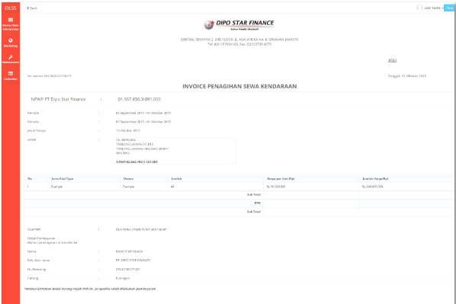

17

16

15

14

13

12

11

10

9

7

6

4

5

3

2

1

Receipt (installment and maintenance has the same format)

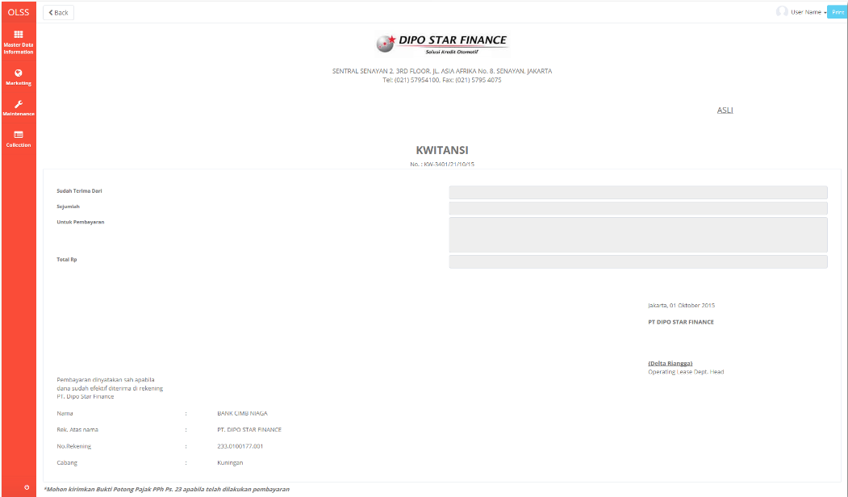

22

21

20

19

18

Maintenance Invoice

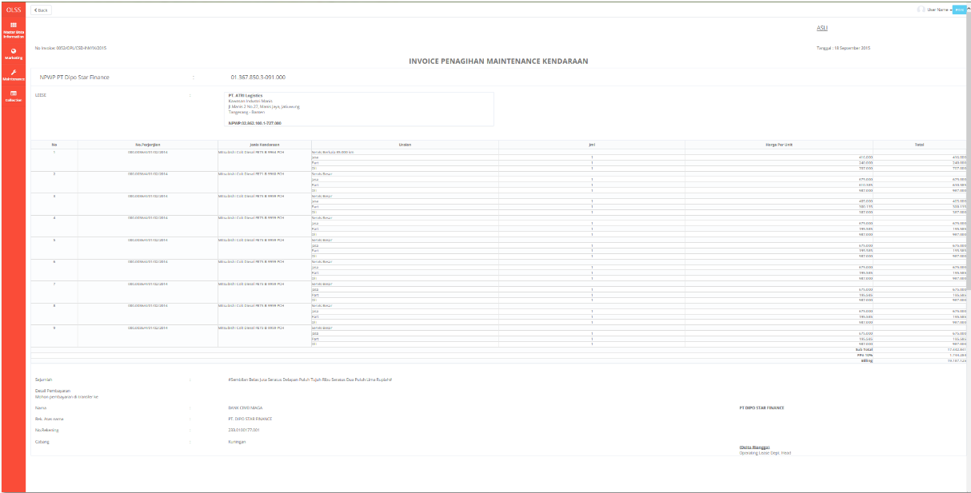

35

34

33

32

31

30

29

28

27

26

25

24

23

Receive Letter



54

53

51

52

47

46

50

48

49

45

44

43

42

**RPT.AE.1.1 Invoice History**

|  |  |  |  |  |
| --- | --- | --- | --- | --- |
| *No.* | *Content* | *Description* | *Source* | *Remarks* |
| 1 | Invoice History Report’s file name | Invoice Report_MMddyyyy_hhmm where MMddyyyy and hhmm is the time when button Print Report is clicked | System Automatic generate |  |
| 2 | Invoice History Monthly Report | Title of the report |  |  |
| 3 | Period | Period monthly Report | Based on selected Start Date and End Date that already select by User when print Report | Format display Report:  MM/dd/yyyy |
| 4 | Page | Number of Report Page | Automatically count by number of page |  |
| 5 | Printed By | Printed By | Sys.CurrentUser |  |
| 6 | Printed Date | Printed Date | Use date at server when button Print Report is clicked |  |
| 7 | DSF Office | Branch Short Name | TB_OPL_Branch.BranchShortName |  |
| 8 | Invoice Number | Installment Invoice Number | TB_BIL_InvoiceReceipt.InstalmentInvoiceNo |  |
| 9 | Receipt Number | Installment Receipt Number | TB_BIL_InvoiceReceipt.InstalmentReceiptNo |  |
| 10 | Maintenance Invoice Number | Maintenance Invoice Number | TB_BIL_InvoiceReceipt.MaintenanceInvoiceNo |  |
| 11 | Maintenance Receipt Number | Maintenance Receipt Number | TB_BIL_InvoiceReceipt.MaintenanceReceiptNo |  |
| 12 | Invoice Status | Invoice Status | TB_BIL_InvoiceReceipt.InvoiceStatus |  |
| 13 | Last Modified By | Last Modified By | TB_BIL_InvoiceReceipt.LastModifiedBy |  |
| 14 | Last Modified Date | Last Modified Date | TB_BIL_InvoiceReceipt.LastModifiedDate |  |

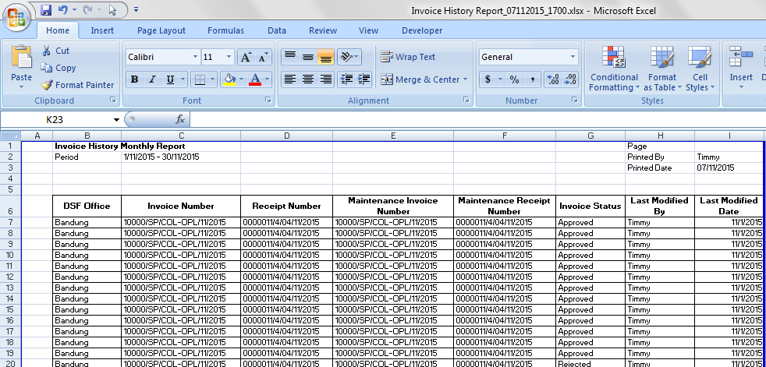

6

5

3

2

1

4

14

13

12

11

10

9

8

7

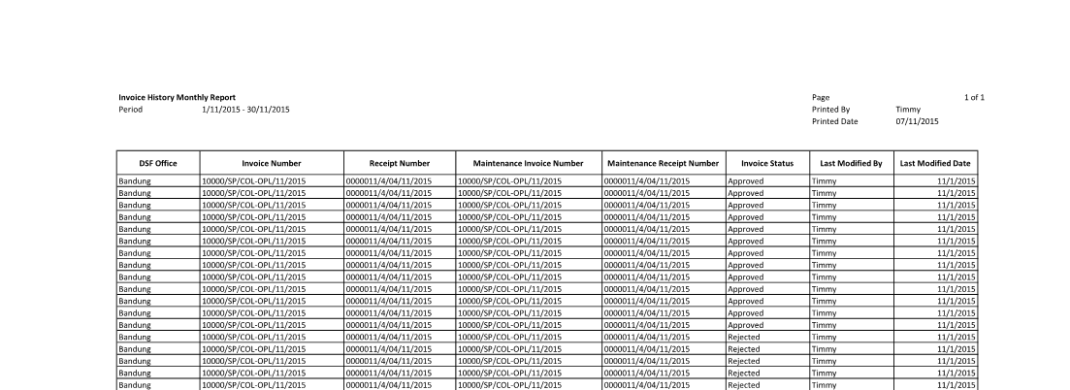

**Note:**

Content number 2, 3, 4, 5 and 6 will be page header format and will be printed in every page.

* 1. Data Structure

**TB_BIL_PaySchedule**

|  |  |  |  |  |  |  |
| --- | --- | --- | --- | --- | --- | --- |
| *Field Name* | *Data Type* | *Length* | *Source* | *Remarks* | *Nullable* | *Mandatory* |
| IdTB_BIL_PaySchedule | *Integer* | *N/A* | TB_BIL_PaySchedule.IdTB_BIL_PaySchedule | ***Primary Key*** | *No* | *Yes* |
| IdOPLAgreement | *Integer* | *N/A* | OPLAgreement.IdOPLAgreement | ***Foreign Key*** | *No* | *Yes* |
| CollectionAmt | *Decimal* | *18,3* | TB_BIL_PaySchedule.CollectionAmt |  | *Yes* | *No* |
| OverdueDays | *Integer* | *5* | TB_BIL_PaySchedule.OverdueDays |  | *Yes* | *No* |
| BillingTotal | *Decimal* | *18,3* | TB_BIL_PaySchedule.BillingTotal |  | *Yes* | *No* |
| Remarks | *Varchar* | *500* | TB_BIL_PaySchedule.Remarks |  | *Yes* | *No* |
| isValid | *Boolean* | *1* | TB_BIL_PaySchedule.isValid |  | *Yes* | *No* |
| CreatedBy | *Varchar* | *50* | TB_BIL_PaySchedule.CreatedBy |  | *No* | *Yes* |
| CreatedDate | *Datetime* | *N/A* | TB_BIL_PaySchedule.CreatedDate |  | *No* | *Yes* |
| LastModifiedBy | *Varchar* | *50* | TB_BIL_PaySchedule.LastModifiedBy |  | *Yes* | *No* |
| LastModifiedDate | *Datetime* | *N/A* | TB_BIL_PaySchedule.LastModifiedDate |  | *Yes* | *No* |

**TB_BIL_PayScheduleDtl**

|  |  |  |  |  |  |  |
| --- | --- | --- | --- | --- | --- | --- |
| *Field Name* | *Data Type* | *Length* | *Source* | *Remarks* | *Nullable* | *Mandatory* |
| IdTB_BIL_PayScheduleDtl | *Integer* | *N/A* | TB_BIL_PayScheduleDetail.IdTB_BIL_PayScheduleDtl | ***Primary Key*** | *No* | *Yes* |
| IdTB_PaySchedule | *Integer* | *N/A* | TB_BIL_PayScheduleDetail.IdTB_PaySchedule | ***Foreign Key*** | *No* | *Yes* |
| PaymentTransType | *Varchar* | *5* | TB_BIL_PayScheduleDetail.PaymentTransType |  | *No* | *Yes* |
| PaymentSchedule | *Datetime* | *N/A* | TB_BIL_PayScheduleDetail.PaymentSchedule |  | *No* | *Yes* |
| BillingAmt | *Decimal* | *18,3* | TB_BIL_PayScheduleDetail.BillingAmt |  | *No* | *Yes* |
| InvoiceIssueDate | *Datetime* | *N/A* | TB_BIL_PayScheduleDetail.InvoiceIssueDate |  | *Yes* | *No* |
| CollectionDate | *Datetime* | *N/A* | TB_BIL_PayScheduleDetail.CollectionDate |  | *Yes* | *No* |
| CollectionAmt | *Decimal* | *18,3* | TB_BIL_PayScheduleDetail.CollectionAmt |  | *Yes* | *No* |
| BreakdownAmt | *Decimal* | *18,3* | TB_BIL_PayScheduleDetail.BreakdownAmt |  | *Yes* | *No* |
| PenaltyAmt | *Decimal* | *18,3* | TB_BIL_PayScheduleDetail.PenaltyAmt |  | *Yes* | *No* |
| OverdueDays | *Integer* | *5* | TB_BIL_PayScheduleDetail.OverdueDays |  | *Yes* | *No* |
| VATAmt | *Decimal* | *18,3* | TB_BIL_PayScheduleDetail |  | *Yes* | *No* |
| isPPH | *Boolean* | *1* | TB_BIL_PayScheduleDetail.VATAmt |  | *Yes* | *No* |
| isSpecialCondition | *Boolean* | *1* | TB_BIL_PayScheduleDetail.isSpecialCondition |  | *No* | *Yes* |
| SpecialDateInvoice | *Datetime* | *N/A* | TB_BIL_PayScheduleDetail.SpecialDateInvoice |  | *No* | *Yes* |
| PPHAmt | *Decimal* | *18,3* | TB_BIL_PayScheduleDetail.PPHAmt |  | *Yes* | *No* |
| Remarks | *Varchar* | *500* | TB_BIL_PayScheduleDetail.Remarks |  | *Yes* | *No* |
| isDraft | *Boolean* | *1* | TB_BIL_PayScheduleDetail.isDraft |  | *No* | *Yes* |
| isValid | *Boolean* | *1* | TB_BIL_PayScheduleDetail.isValid |  | *No* | *Yes* |
| isOverdue | *Boolean* | *1* | TB_BIL_PayScheduleDetail.isOverdue |  | *No* | *Yes* |
| OverdueBucket | *Integer* | *2* | TB_BIL_PayScheduleDetail.OverdueBucket |  | *Yes* | *No* |
| RALIssueDate | *Datetime* | *N/A* | TB_BIL_PayScheduleDetail.RALIssueDate |  | *Yes* | *No* |
| BillingStatus | *Char* | *1* | TB_BIL_PayScheduleDetail.BillingStatus |  | *No* | *Yes* |
| PTPDatePrev | *Datetime* | *N/A* | TB_BIL_PayScheduleDetail.PTPDatePrev |  | *Yes* | *No* |
| PTPDate | *Datetime* | *N/A* | TB_BIL_PayScheduleDetail.PTPDate |  | *Yes* | *No* |
| CreatedDate | *Datetime* | *N/A* | TB_BIL_PayScheduleDetail.CreatedDate |  | *No* | *Yes* |
| CreatedBy | *Varchar* | *50* | TB_BIL_PayScheduleDetail.CreatedBy |  | *No* | *Yes* |
| LastModifiedDate | *Datetime* | *N/A* | TB_BIL_PayScheduleDetail.LastModifiedDate |  | *Yes* | *No* |
| LastModifiedBy | *Varchar* | *50* | TB_BIL_PayScheduleDetail.LastModifiedBy |  | *Yes* | *No* |

**TB_BIL_InvoiceReceipt**

|  |  |  |  |  |  |  |
| --- | --- | --- | --- | --- | --- | --- |
| *Field Name* | *Data Type* | *Length* | *Source* | *Remarks* | *Nullable* | *Mandatory* |
| IdTB_BIL_InvoiceReceipt | *Integer* | *N/A* | TB_BIL_InvoiceReceipt.IdTB_BIL_InvoiceReceipt | ***Primary Key*** | *No* | *Yes* |
| IdTB_BIL_PayScheduleDtl | *Integer* | *N/A* | TB_BIL_PayScheduleDetail.IdTB_BIL_PayScheduleDtl | ***Foreign Key*** | *No* | *Yes* |
| InvoiceNoInstalment | *Varchar* | *50* | TB_BIL_InvoiceReceipt.InvoiceNoInstalment |  | *No* | *Yes* |
| ReceiptNoInstalment | *Varchar* | *50* | TB_BIL_InvoiceReceipt.ReceiptNoInstalment |  | *No* | *Yes* |
| InvoiceNoMaintenance | *Varchar* | *50* | TB_BIL_InvoiceReceipt.InvoiceNoMaintenance |  | *No* | *Yes* |
| ReceiptNoMaintenance | *Varchar* | *50* | TB_BIL_InvoiceReceipt.ReceiptNoMaintenance |  | *No* | *Yes* |
| ReceiveLetterNo | *Varchar* | *50* | TB_BIL_InvoiceReceipt.ReceiveLetterNo |  | *No* | *Yes* |
| InvoiceStatus | *Varchar* | *25* | TB_BIL_InvoiceReceipt.InvoiceStatus |  | *No* | *Yes* |
| DocumentType | *Varchar* | *25* | TB_BIL_InvoiceReceipt.DocumentType |  | *Yes* | *No* |
| DeliveryDate | *Datetime* | *N/A* | TB_BIL_InvoiceReceipt.DeliveryDate |  | *No* | *Yes* |
| DeliveryBy | *Varchar* | *25* | TB_BIL_InvoiceReceipt.DeliveryBy |  | *No* | *Yes* |
| DeliveryRegNo | *Varchar* | *50* | TB_BIL_InvoiceReceipt.DeliveryRegNo |  | *No* | *Yes* |
| Remarks | *Varchar* | *500* | TB_BIL_InvoiceReceipt.Remarks |  | *No* | *Yes* |
| CreatedDate | *Datetime* | *N/A* | TB_BIL_InvoiceReceipt.CreatedDate |  | *No* | *Yes* |
| CreatedBy | *Varchar* | *50* | TB_BIL_InvoiceReceipt.CreatedBy |  | *No* | *Yes* |
| LastModifiedDate | *Datetime* | *N/A* | TB_BIL_InvoiceReceipt.LastModifiedDate |  | *No* | *Yes* |
| LastModifiedBy | *Varchar* | *50* | TB_BIL_InvoiceReceipt.LastModifiedBy |  | *No* | *Yes* |

**TB_BIL_MaintenanceDtl**

|  |  |  |  |  |  |  |
| --- | --- | --- | --- | --- | --- | --- |
| *Field Name* | *Data Type* | *Length* | *Source* | *Remarks* | *Nullable* | *Mandatory* |
| IdTB_BIL_MaintenanceDtl | *Integer* | *N/A* | TB_BIL_MaintenanceDtl.IdTB_BIL_MaintenanceDtl | ***Primary Key*** | *No* | *Yes* |
| IdTB_BIL_PayScheduleDtl | *Integer* | *N/A* | TB_BIL_PayScheduleDetail.IdTB_BIL_PayScheduleDtl | ***Foreign Key*** | *No* | *Yes* |
| IdOPAgreement | *Integer* | *N/A* | OPLAgreement.IdOPLAgreement | ***Foreign Key*** | *No* | *Yes* |
| IdOPLUObjLease | *Integer* | *N/A* | OPLUObjLease.IdOPLUObjLease | ***Foreign Key*** | *No* | *Yes* |
| MaintenanceType | *Varchar* | *20* | TB_BIL_MaintenanceDtl.MaintenanceType |  | *No* | *Yes* |
| MaintenanceCategory | *Varchar* | *20* | TB_BIL_MaintenanceDtl.MaintenanceCategory |  | *No* | *Yes* |
| IdSupplier | *Varchar* | *100* | Supplier.IdSupplier |  | *Yes* | *No* |
| ServiceDate | *Datetime* | *N/A* | TB_BIL_MaintenanceDtl.ServiceDate |  | *No* | *Yes* |
| ServiceItem | *Varchar* | *50* | TB_BIL_MaintenanceDtl.ServiceItem |  | *Yes* | *No* |
| ServiceCost | *Decimal* | *18,3* | TB_BIL_MaintenanceDtl.ServiceCost |  | *Yes* | *No* |
| PPNTax | *Decimal* | *18,3* | TB_BIL_MaintenanceDtl.PPN_Tax |  | *Yes* | *No* |
| PPHTax | *Decimal* | *18,3* | TB_BIL_MaintenanceDtl.PPH_Tax |  | *Yes* | *No* |
| IsBilled | *Boolean* | *1* | TB_BIL_MaintenanceDtl.IsBilled |  | *Yes* | *No* |
| TotalIncludeTax | *Decimal* | *18,3* | TB_BIL_MaintenanceDtl.TotalIncludeTax |  | *Yes* | *No* |
| CreatedDate | *Datetime* | *N/A* | TB_BIL_MaintenanceDtl.CreatedDate |  | *Yes* | *No* |
| CreatedBy | *Varchar* | *50* | TB_BIL_MaintenanceDtl.CreatedBy |  | *Yes* | *No* |
| LastModifiedDate | *Datetime* | *N/A* | TB_BIL_MaintenanceDtl.LastModifiedDate |  | *Yes* | *No* |
| LastModifiedBy | *Varchar* | *50* | TB_BIL_MaintenanceDtl.LastModifiedBy |  | *Yes* | *No* |

**TB_BIL_ReminderMemoHistory**

|  |  |  |  |  |  |  |
| --- | --- | --- | --- | --- | --- | --- |
| *Field Name* | *Data Type* | *Length* | *Source* | *Remarks* | *Nullable* | *Mandatory* |
| IdTB_BIL_ReminderMemo | *Integer* | *N/A* | TB_BIL_ReminderMemoHistory.IdTB_BIL_ReminderMemo | ***Primary Key*** | *No* | *Yes* |
| IdTB_BIL_PaySchedule | *Integer* | *N/A* | TB_BIL_PaySchedule.IdTB_BIL_PaySchedule | ***Foreign Key*** | *No* | *Yes* |
| ReminderDate | *Datetime* | *N/A* | TB_BIL_ReminderMemoHistory.ReminderDate |  | *Yes* | *No* |
| ReminderType | *Varchar* | *50* | TB_BIL_ReminderMemoHistory.ReminderType |  | *Yes* | *No* |
| Response | *Varchar* | *500* | TB_BIL_ReminderMemoHistory |  | *Yes* | *No* |
| CreatedDate | *Datetime* | *N/A* | TB_BIL_ReminderMemoHistory.CreatedDate |  | *No* | *Yes* |
| CreatedBy | *Varchar* | *50* | TB_BIL_ReminderMemoHistory.CreatedBy |  | *No* | *Yes* |
| LastModifiedDate | *Datetime* | *N/A* | TB_BIL_ReminderMemoHistory.LastModifiedDate |  | *No* | *Yes* |
| LastModifiedBy | *Varchar* | *50* | TB_BIL_ReminderMemoHistory.LastModifiedBy |  | *No* | *Yes* |

**TB_BIL_PaySchedule_History**

|  |  |  |  |  |  |  |
| --- | --- | --- | --- | --- | --- | --- |
| *Field Name* | *Data Type* | *Length* | *Source* | *Remarks* | *Nullable* | *Mandatory* |
| ProcessId | *Integer* | *N/A* | TB_BIL_PaySchedule_History.ProcessId | ***Primary Key***  *New GUID* | *No* | *Yes* |
| OriginalId | *Integer* | *N/A* | TB_BIL_BIL_PaySchedule_History.OriginalId | ***Foreign Key*** | *No* | *Yes* |
| CreatedDate | *Datetime* | *N/A* | TB_BIL_BIL_PaySchedule_History.CreatedDate |  | *No* | *Yes* |
| CreatedBy | *Varchar* | *50* | TB_BIL_BIL_PaySchedule_History.CreatedBy |  | *No* | *Yes* |
| Action | *Varchar* | *100* | TB_BIL_BIL_PaySchedule_History.Action |  | *No* | *Yes* |

**TB_BIL_ PaySchedule _History_Dtl**

|  |  |  |  |  |  |  |
| --- | --- | --- | --- | --- | --- | --- |
| *Field Name* | *Data Type* | *Length* | *Source* | *Remarks* | *Nullable* | *Mandatory* |
| ProcessId | *Integer* | *N/A* | TB_BIL_PaySchedule_HistoryDtl | ***Primary Key*** | *No* | *Yes* |
| IdTB_BIL_PaySchedule | *Integer* | *N/A* | TB_BIL_PaySchedule.IdTB_BIL_PaySchedule |  | *Yes* | *No* |
| IdOPLAgreement | *Integer* | *N/A* | OPLAgreement.IdOPLAgreement |  | *Yes* | *No* |
| CollectionAmt | *Decimal* | *18,3* | TB_BIL_PaySchedule.CollectionAmt |  | *Yes* | *No* |
| OverdueDays | *Integer* | *5* | TB_BIL_PaySchedule.OverdueDays |  | *Yes* | *No* |
| BillingTotal | *Decimal* | *18,3* | TB_BIL_PaySchedule.BillingTotal |  | *Yes* | *No* |
| Remarks | *Varchar* | *500* | TB_BIL_PaySchedule.Remarks |  | *Yes* | *No* |
| isValid | *Boolean* | *1* | TB_BIL_PaySchedule.isValid |  | *Yes* | *No* |
| CreatedBy | *Varchar* | *50* | TB_BIL_PaySchedule.CreatedBy |  | *No* | *Yes* |
| CreatedDate | *Datetime* | *N/A* | TB_BIL_PaySchedule.CreatedDate |  | *No* | *Yes* |
| LastModifiedBy | *Varchar* | *50* | TB_BIL_PaySchedule.LastModifiedBy |  | *Yes* | *No* |
| LastModifiedDate | *Datetime* | *N/A* | TB_BIL_PaySchedule.LastModifiedDate |  | *Yes* | *No* |

**TB_BIL_PayScheduleDtl_History**

|  |  |  |  |  |  |  |
| --- | --- | --- | --- | --- | --- | --- |
| *Field Name* | *Data Type* | *Length* | *Source* | *Remarks* | *Nullable* | *Mandatory* |
| ProcessId | *Integer* | *N/A* | TB_BIL_PayScheduleDetail_History.ProcessId | ***Primary Key***  *New GUID* | *No* | *Yes* |
| OriginalId | *Integer* | *N/A* | TB_BIL_PayScheduleDetail_History.OriginalId | ***Foreign Key*** | *No* | *Yes* |
| CreatedDate | *Datetime* | *N/A* | TB_BIL_PayScheduleDetail_History.CreatedDate |  | *No* | *Yes* |
| CreatedBy | *Varchar* | *50* | TB_BIL_PayScheduleDetail_History.CreatedBy |  | *No* | *Yes* |
| Action | *Varchar* | *100* | TB_BIL_PayScheduleDetail_History.Action |  | *No* | *Yes* |

**TB_BIL_ PayScheduleDtl _History_Dtl**

|  |  |  |  |  |  |  |
| --- | --- | --- | --- | --- | --- | --- |
| *Field Name* | *Data Type* | *Length* | *Source* | *Remarks* | *Nullable* | *Mandatory* |
| ProcessId | *Integer* | *N/A* | TB_BIL_PayScheduleDtl.IdProcee | ***Primary key***  *New GUID* | *No* | *Yes* |
| IdTB_BIL_PayScheduleDtl | *Integer* | *N/A* | TB_BIL_PayScheduleDtl.IdTB_BIL_PayScheduleDtl |  | *Yes* | *No* |
| IdTB_PaySchedule | *Integer* | *N/A* | TB_BIL_PayScheduleDtl.IdTB_PaySchedule |  | *Yes* | *No* |
| PaymentTransType | *Varchar* | *5* | TB_BIL_PayScheduleDtl.PaymentTransType |  | *Yes* | *No* |
| PaymentSchedule | *Datetime* | *N/A* | TB_BIL_PayScheduleDtl.PaymentSchedule |  | *Yes* | *No* |
| BillingAmt | *Decimal* | *18,3* | TB_BIL_PayScheduleDtl.BillingAmt |  | *Yes* | *No* |
| InvoiceIssueDate | *Datetime* | *N/A* | TB_BIL_PayScheduleDtl.InvoiceIssueDate |  | *Yes* | *No* |
| CollectionDate | *Datetime* | *N/A* | TB_BIL_PayScheduleDtl.CollectionDate |  | *Yes* | *No* |
| CollectionAmt | *Decimal* | *18,3* | TB_BIL_PayScheduleDtl.CollectionAmt |  | *Yes* | *No* |
| BreakdownAmt | *Decimal* | *18,3* | TB_BIL_PayScheduleDtl.BreakdownAmt |  | *Yes* | *No* |
| PenaltyAmt | *Decimal* | *18,3* | TB_BIL_PayScheduleDtl.PenaltyAmt |  | *Yes* | *No* |
| OverdueDays | *Integer* | *5* | TB_BIL_PayScheduleDtl.OverdueDays |  | *Yes* | *No* |
| VATAmt | *Decimal* | *18,3* | TB_BIL_PayScheduleDtl |  | *Yes* | *No* |
| isPPH | *Boolean* | *1* | TB_BIL_PayScheduleDtl.VATAmt |  | *Yes* | *No* |
| isSpecialCondition | *Boolean* | *1* | TB_BIL_PayScheduleDtl.isSpecialCondition |  | *Yes* | *No* |
| SpecialDateInvoice | *Datetime* | *N/A* | TB_BIL_PayScheduleDtl.SpecialDateInvoice |  | *Yes* | *No* |
| PPHAmt | *Decimal* | *18,3* | TB_BIL_PayScheduleDtl.PPHAmt |  | *Yes* | *No* |
| Remarks | *Varchar* | *500* | TB_BIL_PayScheduleDtl.Remarks |  | *Yes* | *No* |
| isDraft | *Boolean* | *1* | TB_BIL_PayScheduleDtl.isDraft |  | *Yes* | *No* |
| isValid | *Boolean* | *1* | TB_BIL_PayScheduleDtl.isValid |  | *Yes* | *No* |
| isOverdue | *Boolean* | *1* | TB_BIL_PayScheduleDtl.isOverdue |  | *Yes* | *No* |
| OverdueBucket | *Integer* | *2* | TB_BIL_PayScheduleDtl.OverdueBucket |  | *Yes* | *No* |
| RALIssueDate | *Datetime* | *N/A* | TB_BIL_PayScheduleDtl.RALIssueDate |  | *Yes* | *No* |
| BillingStatus | *Char* | *1* | TB_BIL_PayScheduleDtl.BillingStatus |  | *Yes* | *No* |
| PTPDatePrev | *Datetime* | *N/A* | TB_BIL_PayScheduleDtl.PTPDatePrev |  | *Yes* | *No* |
| PTPDate | *Datetime* | *N/A* | TB_BIL_PayScheduleDtl.PTPDate |  | *Yes* | *No* |
| CreatedDate | *Datetime* | *N/A* | TB_BIL_PayScheduleDtl.CreatedDate |  | *No* | *Yes* |
| CreatedBy | *Varchar* | *50* | TB_BIL_PayScheduleDtl.CreatedBy |  | *No* | *Yes* |
| LastModifiedDate | *Datetime* | *N/A* | TB_BIL_PayScheduleDtl.LastModifiedDate |  | *Yes* | *No* |
| LastModifiedBy | *Varchar* | *50* | TB_BIL_PayScheduleDtl.LastModifiedBy |  | *Yes* | *No* |

**TB_BIL_InvoiceReceipt_History**

|  |  |  |  |  |  |  |
| --- | --- | --- | --- | --- | --- | --- |
| *Field Name* | *Data Type* | *Length* | *Source* | *Remarks* | *Nullable* | *Mandatory* |
| ProcessId | *Integer* | *N/A* | TB_BIL_Invoice_History.ProcessId | ***Primary Key***  *New GUID* | *No* | *Yes* |
| OriginalId | *Integer* | *N/A* | TB_BIL_Invoice_History.OriginalId | ***Foreign Key*** | *No* | *Yes* |
| CreatedDate | *Datetime* | *N/A* | TB_BIL_Invoice_History.CreatedDate |  | *No* | *Yes* |
| CreatedBy | *Varchar* | *50* | TB_BIL_Invoice_History.CreatedBy |  | *No* | *Yes* |
| Action | *Varchar* | *100* | TB_BIL_Invoice_History.Action |  | *No* | *Yes* |

**TB_BIL_InvoiceReceipt_History_Dtl**

|  |  |  |  |  |  |  |
| --- | --- | --- | --- | --- | --- | --- |
| *Field Name* | *Data Type* | *Length* | *Source* | *Remarks* | *Nullable* | *Mandatory* |
| ProcessId | *Integer* | *N/A* | TB_BIL_Invoice_History_Dtl.ProcessId | ***Primary Key***  *New GUID* | *No* | *Yes* |
| InvoiceNo | *Varchar* | *20* | TB_BIL_Invoice.InvoiceNo |  | *No* | *Yes* |
| InvoiceStatus | *Varchar* | *25* | TB_BIL_Invoice.InvoiceStatus |  | *No* | *Yes* |
| InvoiceIssueDate | *Datetime* | *N/A* | TB_BIL_Invoice.InvoiceIssueDate |  | *No* | *Yes* |
| DocumentType | *Varchar* | *25* | TB_BIL_Invoice.DocumentType |  | *No* | *Yes* |
| DeliveryDate | *Datetime* | *N/A* | TB_BIL_Invoice.ValidUntil |  | *Yes* | *No* |
| Remarks | *Varchar* | *50* | TB_BIL_Invoice.Remarks |  | *Yes* | *No* |
| CreatedDate | *Datetime* | *N/A* | TB_BIL_Invoice.CreatedDate |  | *No* | *Yes* |
| CreatedBy | *Varchar* | *50* | TB_BIL_Invoice.CreatedBy |  | *No* | *Yes* |
| LastModifiedDate | *Datetime* | *N/A* | TB_BIL_Invoice.LastModifiedDate |  | *Yes* | *No* |
| LastModifiedBy | *Varchar* | *50* | TB_BIL_Invoice.LastModifiedBy |  | *Yes* | *No* |

**TB_BIL_MaintenanceDtl_History**

|  |  |  |  |  |  |  |
| --- | --- | --- | --- | --- | --- | --- |
| *Field Name* | *Data Type* | *Length* | *Source* | *Remarks* | *Nullable* | *Mandatory* |
| ProcessId | *Integer* | *N/A* | TB_BIL_PayScheduleDetail_History.ProcessId | ***Primary Key***  *New GUID* | *No* | *Yes* |
| OriginalId | *Integer* | *N/A* | TB_BIL_PayScheduleDetail_History.OriginalId | ***Foreign Key*** | *No* | *Yes* |
| CreatedDate | *Datetime* | *N/A* | TB_BIL_PayScheduleDetail_History.CreatedDate |  | *No* | *Yes* |
| CreatedBy | *Varchar* | *25* | TB_BIL_PayScheduleDetail_History.CreatedBy |  | *No* | *Yes* |
| Action | *Varchar* | *100* | TB_BIL_PayScheduleDetail_History.Action |  | *No* | *Yes* |

**TB_BIL_MaintenanceDtl_History_Dtl**

|  |  |  |  |  |  |  |
| --- | --- | --- | --- | --- | --- | --- |
| *Field Name* | *Data Type* | *Length* | *Source* | *Remarks* | *Nullable* | *Mandatory* |
| IdTB_BIL_MaintenanceDtl | *Integer* | *N/A* | TB_BIL_MaintenanceDtl.IdTB_BIL_MaintenanceDtl | ***Primary Key*** | *No* | *Yes* |
| IdTB_BIL_PayScheduleDtl | *Integer* | *N/A* | TB_BIL_PayScheduleDetail.IdTB_BIL_PayScheduleDtl | ***Foreign Key*** | *No* | *Yes* |
| IdOPAgreement | *Integer* | *N/A* | OPLAgreement.IdOPLAgreement | ***Foreign Key*** | *No* | *Yes* |
| IdOPLUObjLease | *Integer* | *N/A* | OPLUObjLease.IdOPLUObjLease | ***Foreign Key*** | *No* | *Yes* |
| MaintenanceType | *Varchar* | *20* | TB_BIL_MaintenanceDtl.MaintenanceType |  | *No* | *Yes* |
| MaintenanceCategory | *Varchar* | *20* | TB_BIL_MaintenanceDtl.MaintenanceCategory |  | *No* | *Yes* |
| IdSupplier | *Integer* | *N/A* | Supplier.IdSupplier |  | *Yes* | *No* |
| ServiceDate | *Datetime* | *N/A* | TB_BIL_MaintenanceDtl.ServiceDate |  | *No* | *Yes* |
| ServiceItem | *Varchar* | *50* | TB_BIL_MaintenanceDtl.ServiceItem |  | *Yes* | *No* |
| ServiceCost | *Decimal* | *18,3* | TB_BIL_MaintenanceDtl.ServiceCost |  | *Yes* | *No* |
| PPNTax | *Decimal* | *18,3* | TB_BIL_MaintenanceDtl.PPN_Tax |  | *Yes* | *No* |
| PPHTax | *Decimal* | *18,3* | TB_BIL_MaintenanceDtl.PPH_Tax |  | *Yes* | *No* |
| IsBilled | *Boolean* | *1* | TB_BIL_MaintenanceDtl.IsBilled |  | *Yes* | *No* |
| TotalIncludeTax | *Decimal* | *18,3* | TB_BIL_MaintenanceDtl.TotalIncludeTax |  | *Yes* | *No* |
| CreatedDate | *Datetime* | *N/A* | TB_BIL_MaintenanceDtl.CreatedDate |  | *Yes* | *No* |
| CreatedBy | *Varchar* | *50* | TB_BIL_MaintenanceDtl.CreatedBy |  | *Yes* | *No* |
| LastModifiedDate | *Datetime* | *N/A* | TB_BIL_MaintenanceDtl.LastModifiedDate |  | *Yes* | *No* |
| LastModifiedBy | *Varchar* | *50* | TB_BIL_MaintenanceDtl.LastModifiedBy |  | *Yes* | *No* |

* 1. Entity Relationship Diagram

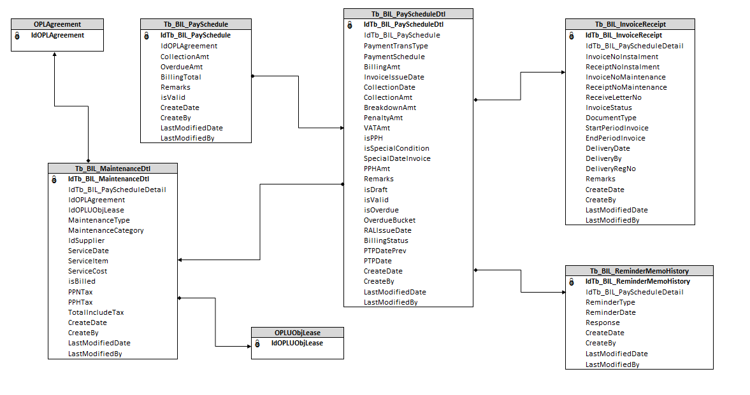

**APPENDIX**

Configuration Access for Monitor Billing Schedule:

|  |  |  |  |  |  |  |  |
| --- | --- | --- | --- | --- | --- | --- | --- |
| **User** | **Branch** | **Functions** | | | | | |
| **Display List** | **Create** | **Edit** | **View** | **Print Form** | **Print Report** |
| PIC Collection | One | V | V | V | V | V | V |
| Area |  |  |  |  |  |  |
| All |  |  |  |  |  |  |
| Head of Branch | One | V |  |  | V | V | V |
| Area |  |  |  |  |  |  |
| All |  |  |  |  |  |  |
| Head of Department | One |  |  |  |  |  |  |
| Area |  |  |  |  |  |  |
| All | V |  |  | V | V | V |
| Regional Manager | One |  |  |  |  |  |  |
| Area | V |  |  | V | V | V |
| All |  |  |  |  |  |  |
| Advisor | One |  |  |  |  |  |  |
| Area |  |  |  |  |  |  |
| All | V |  |  | V | V | V |
| Director | One |  |  |  |  |  |  |
| Area |  |  |  |  |  |  |
| All | V |  |  | V | V | V |
| President Director | One |  |  |  |  |  |  |
| Area |  |  |  |  |  |  |
| All | V |  |  | V | V | V |
| Shareholder's Meeting | One |  |  |  |  |  |  |
| Area |  |  |  |  |  |  |
| All | V |  |  | V | V | V |
|  |  |  |  |  |  |  |  |
| **Legend:** |  |  |  |  |  |  |  |
| V = Have the access |  |  |  |  |  |  |  |